Fraud Detection in Financial Transactions Using Supervised and Unsupervised Machine Learning Algorithms

Submitted to
The University of Roehampton

In partial fulfilment of the requirements
for the degree of
Master of Science
in
Data Science
By
Nandamol Narayanan

Declaration
I hereby certify that this report constitutes my own work, that where the language of others is used, quotation marks so indicate, and that appropriate credit is given where I have used the language, ideas, expressions, or writings of others.

I declare that this report describes the original work that has not been previously presented for the award of any other degree of any other institution.
Nandamol Narayanan
03/07/2026

Nandamol Narayanan

Acknowledgements
I would like to thank my supervisor for their guidance, feedback and continuous support during this project. I also express my gratitude to my lecturers and the University for imparting knowledge and resources that enabled me to carry out this research. Also, I would like to thank my family and friends who have encouraged, been patient with, and supported me throughout my studies and the writing of this dissertation.

Abstract
In the era of digital payment systems and online banking services, financial fraud is becoming a growing problem for financial institutions. Traditional rule-based fraud detection methods are ineffective against new kinds of fraud; there is a need for more intelligent and adaptive methods. The current study compares the performance of supervised and unsupervised machine learning algorithms based on an existing dataset of 10,000 financial transactions, with a view to identifying fraudulent transactions. The researcher develops a machine learning system in Python with Jupyter Notebook, including “data preparation, feature engineering, exploratory data analysis, model building and evaluation”. Three supervised algorithms (“Logistic Regression, Random Forest and XGBoost”) and three unsupervised algorithms (“Isolation Forest, Local Outlier Factor and K-Means clustering”) were developed and evaluated in terms of “Accuracy, Precision, Recall, F1-score and ROC-AUC”. The severe class imbalance in the dataset is overcome by using the “Synthetic Minority Oversampling Technique (SMOTE)” for supervised model training. The experimental results showed that none of the algorithms performed better than the others in all the evaluation measures. Logistic Regression had the best recall, while among the models tested, Isolation Forest had the best overall classification performance while maintaining a high fraud detection capability. The results suggest that the hybrid approach of combining supervised classification with anomaly detection approaches can hold potential for enhancing financial fraud detection in practical applications.

Table of Contents
Declaration ii
Acknowledgements iii
Abstract iv
Chapter 1 Introduction 1
1.1 Problem Description, Context and Motivation 1
1.2 Objectives 1
1.3 Methodology 2
1.3.1 Design 2
1.3.2 Testing and Evaluation 3
1.3.3 Project Management 3
1.3.4 Technologies and Processes 3
1.4 Legal, Social, Ethical and Professional Considerations 3
1.5 Background 3
1.6 Structure of Report 4
Chapter 2 Literature – Technology Review 5
2.1 Literature Review 5
2.1.1 Financial Fraud Detection 5
2.1.2 Machine Learning in Financial Fraud Detection 5
2.1.3 Supervised Machine Learning Algorithms 6
2.1.4 Unsupervised Machine Learning Algorithms 6
2.1.5 Research Gap 7
2.2 Technology Review 8
2.3 Summary 9

Chapter 3 Implementation 11
3.1 Introduction 11
3.2 System Design and Implementation Framework 11
3.3 Development Environment 12
3.4 Dataset Acquisition and Initial Exploration 12
3.5 Data Cleaning and Feature Engineering 14
3.5.1 Data Cleaning 15
3.5.2 Feature Engineering 17
3.5.3 Prepared Dataset 18
3.6 Exploratory Data Analysis (EDA) 19
3.6.1 Fraud Distribution 19
3.6.2 Transaction Amount Analysis 20
3.6.3 Merchant Category Analysis 21
3.6.4 Device Type Analysis 22
3.6.5 Customer Location Analysis 23
3.6.6 Fraud by Hour of Day 23
3.6.7 Fraud by Weekday 24
3.6.8 Correlation Analysis 25
3.7 Data Pre-processing for Machine Learning 26
3.8 Supervised Machine Learning Models 28
3.9 Unsupervised Machine Learning Models 31
Chapter 4 Evaluation and Results 34
4.1 Related Works 34
4.2 Evaluation Methodology 34
4.3 Experimental Results 35
4.3.1 Logistic Regression 35
4.3.2 Random Forest 38
4.3.3 XGBoost 40
4.3.4 Isolation Forest 43
4.3.5 Local Outlier Factor (LOF) 45
4.3.6 K-Means Clustering 47
4.4 Comparative Analysis 47
4.5 Strengths and Limitations of Developed Framework 49
4.6 Chapter Summary 49
Chapter 5 Conclusion 51
5.1 Future Work 52
5.2 Reflection 52
References 54
Appendix A: Project Proposal 57
Appendix B: Project Management IX
Appendix C: Artefact/Dataset XII

List of Figures
Figure 1: System workflow 11
Figure 2: Data Loading 13
Figure 3: Dataset Information 13
Figure 4: Statistical Summary 14
Figure 5: Fraud Distribution 14
Figure 6: Check Missing and Duplicate Values 15
Figure 7: Unique Values 16
Figure 8: Feature Engineering 17
Figure 9: Remove Unnecessary Columns 18
Figure 10: Fraud vs Non-Fraud Transactions 19
Figure 11: Fraud Transaction Percentage 19
Figure 12: Transaction Amount by Fraud Status 20
Figure 13: Merchant Category Analysis 21
Figure 14: Fraud by Device Type 22
Figure 15: Fraud by Customer Location 23
Figure 16: Fraud by Hour of Day 24
Figure 17: Fraud by Weekday 24
Figure 18: Correlation Analysis 25
Figure 19: Encoding 26
Figure 20: Separate Features and Target 26
Figure 21: Train-Test Split 27
Figure 22: Standardise Numerical Variables and Check Class Distribution 27
Figure 23: Apply SMOTE 28
Figure 24: Before and after SMOTE 28
Figure 25: Train Logistic Regression 29
Figure 26: Train Random Forest 30
Figure 27: Train XGBoost Classifier 31
Figure 28: Train Isolation Forest 31
Figure 29: Train Local Outlier Factor (LOF) 32
Figure 30: Train K-Means Clustering 32
Figure 31: Classification Report of Logistic Regression (LR) 35
Figure 32: Confusion Matrix of LR 36
Figure 33: ROC curve of LR 37
Figure 34: Classification Report Of Random Forest (RF) 38
Figure 35: Confusion Matrix of RF 38
Figure 37: Feature Importance of Random Forest 40
Figure 38: Model evaluation of XGBoost 41
Figure 39: Confusion matrix XGBoost 41
Figure 40: ROC curve of XGBoost 42
Figure 41: XGBoost Feature Importance 42
Figure 42: Classification Report of Isolation Forest 43
Figure 43: Isolation Forest Confusion Matrix 44
Figure 44: Isolation Forest ROC Curve 45
Figure 46: Confusion matrix 46
Figure 47: Classification report of K-Means Clustering 47
Figure 48: Comparison analysis 48

List of Tables
Table 1: Technology Selection 9

Introduction

1.1 Problem Description, Context and Motivation
The research defined that digital banking and e-commerce, mobile payment and online financial services have all seen rapid growth, changing how individuals and organisations manage their finances. These technologies have enhanced the speed, access and convenience of transactions, but opened the door for more fraudulent activity. Financial fraud, such as “credit card fraud, identity theft, account takeover and unauthorised online transactions”, is a major issue for financial institutions, businesses and customers. The most common approach to fraud detection has been to implement pre-defined rules and manually set thresholds, which is less effective at detecting new fraud patterns and emerging fraud trends [3]. The challenge of this research is that traditional fraud detection techniques do not effectively detect fraudulent transactions and do not have the ability to effectively reduce false positive alerts. The impact of this challenge is seen in banks, payment service providers, fintech organisations and the consumers, resulting in financial losses, costs and damages to reputation and loss of customer trust. Digital financial transactions are growing in volume across the globe, and organisations need solutions that are intelligent and adaptive in order to identify convoluted transaction behaviours in real-time. The use of “machine learning” is an advantageous way to accelerate fraud detection by automatically discovering patterns in the transaction data. Supervised learning algorithms are used to classify transactions based on labelled historical data, while unsupervised learning algorithms can be used to identify anomalous behaviour, which does not require a labelled sample. Supervised learning algorithms can be used to classify transactions based on labelled historical data, whereas unsupervised learning algorithms can be used to detect anomalous behaviour without a labelled sample [4]. But there has not been much research that compares these two approaches in a comprehensive manner with a consistent evaluation framework. This study thus seeks to design and evaluate various supervised and unsupervised machine learning algorithms to identify the best algorithm for detecting financial fraud, which would contribute to more secure, accurate and reliable digital financial systems.

1.2 Objectives
The main agenda of the project is to create and compare supervised and unsupervised machine learning models to detect fraudulent financial transactions using a publicly available dataset, which is named “Financial Transaction for Fraud Detection Research”.
- To develop an Exploratory Data Analysis to learn about the distribution of transactions and fraud.
- To preprocess the data by imputing missing values, encoding categorical variables and scaling numerical variables.
- To create supervised learning models such as “Logistic Regression, Random Forest and Extreme Gradient Boosting (XGBoost)”.
- To develop unsupervised anomaly detection algorithms like Isolation Forest, Local Outlier Factor and K-Means Clustering.
- To underscore the performances of models by “Accuracy, Precision, Recall, F1-score and Receiver Operating Characteristic Area Under the Curve (ROC-AUC)”.
- To explain the difference between supervised and unsupervised learning methods and determine the best method for detecting fraud.
- To deliver suggestions on how to apply machine learning models to detect fraud in financial institutions.

1.3 Methodology
The methodology of this project is quantitative research with secondary data collected from the Kaggle database. The dataset includes data on transaction attributes, customer behaviour, and fraud flags, which can be used to develop and assess machine learning models.

1.3.1 Design
The project will develop through the full machine learning development lifecycle. Initially, exploratory data analysis will be performed to understand data quality, fraud distribution and relationships between variables. Then, data preprocessing techniques, such as missing value treatment, categorical encoding, feature scaling and feature engineering, will be used. Appropriate resampling methods will be used where necessary to overcome class imbalance and to enhance model performance. Labelled transaction data will be used to train supervised learning models such as “Logistic Regression, Random Forest and XGBoost” after the data is preprocessed. The “Isolation Forest, Local Outlier Factor, and K-Means Clustering” are unsupervised learning techniques that will then be used to identify fraudulent transaction behaviour without the need for labels being provided during the model training process.

1.3.2 Testing and Evaluation
The dataset will be split into training and testing sets to provide unbiased model evaluation. The “accuracy, precision, recall, F1-score and ROC-AUC” will be used to evaluate performance. Confusion matrices and feature importance analysis will also be used to understand the model behaviour and the effectiveness of the algorithms. These evaluation metrics offer a balanced evaluation of fraud detection performance, especially when operating on very imbalanced datasets.

1.3.3 Project Management
The project will be managed in a structured development schedule with the help of a Gantt chart, which will keep track of the project progress for each of the phases of the dissertation. Literature review, data preparation, development of the model, model evaluation, report writing and submission will be done in accordance with prespecified milestones to ensure efficient project management and timely completion.

1.3.4 Technologies and Processes
The researcher will develop the project with the help of Python, and the environment is the Jupyter Notebook environment. The important libraries used are “Pandas, NumPy, and Scikit-learn for data manipulation, Matplotlib and Seaborn for visualisation”, and XGBoost for gradient boosting classification. The technologies have been chosen for offering solid, well-documented and widely used machine learning research tools.

1.4 Legal, Social, Ethical and Professional Considerations
In this research, no personally identifiable information is processed, and a publicly available and anonymised financial transaction dataset is used. The study will adhere to the principles of the “UK General Data Protection Regulation (UK GDPR)” and the Data Protection Act 2018, and the dataset will only be used for academic research. Ethical considerations include minimising algorithmic bias and decreasing false positive predictions, which could negatively affect legitimate customers [6]. In response to these concerns, there will be multiple metrics used to evaluate model fairness and performance, in addition to accuracy. Academically, the project will uphold integrity by ensuring proper referencing, clear reporting of methods and results, and responsible and ethical machine learning research with clear documentation of assumptions and limitations.

1.5 Background
With the rapid development of digital financial services, the significance of fraud detection in the banking and financial industry has grown. The traditional rule-based systems, which are still used, are not very efficient in detecting new and complex fraud patterns and need frequent manual updates [5]. As a result, machine learning has achieved efficiency because it can detect intricate transaction patterns and accelerate the accuracy of fraud detection. Supervised algorithms like “Random Forest and XGBoost” have proved useful for dealing with labelled data, while unsupervised algorithms like “Isolation Forest and Local Outlier Factor” are useful for detecting previously unseen anomalies ( Chen and Guestrin, 2016; Liu et al., 2008). In this study, these methods are compared to determine which the best method for detecting financial fraud.

1.6 Structure of Report
The rest of this dissertation is divided into four chapters. The literature review and technology review are presented in Chapter 2, which discusses the various studies and technologies related to financial fraud detection and machine learning algorithms. Chapter 3 explains the process of implementation, which involves data pre-processing, feature engineering, model building and system implementation. The experimental results are provided in Chapter 4, and the performance of each machine learning model is evaluated and compared to the supervised and unsupervised approaches. Also, Chapter 5 summarises the key findings, considers future directions and project constraints, and reflects on the overall research process.

Literature – Technology Review

2.1 Literature Review

2.1.1 Financial Fraud Detection
The research has underscored that online banking, digital payment systems, electronic commerce and mobile financial services have created a major challenge in financial fraud. These technologies have made transactions faster and easier to access, but have also enabled new forms of fraud, like “credit card fraud, identity theft, account takeover, and money laundering”. These attacks result in significant economic damages and have a detrimental impact on consumer trust in digital financial services. The traditional methods of fraud detection are primarily based on predefined business rules and statistical thresholds to detect fraudulent transactions. But because fraudsters constantly change their tactics, these systems face challenges identifying new and emerging fraud patterns. Ngai et al. [4] noted that rule-based systems frequently need to be updated, and that they often produce high false positive rates, while Phua et al. [5] reported that traditional approaches are not able to capture complex behavioural patterns in transaction data. As a result, machine learning has proven itself as a viable solution, learning transaction patterns and gaining greater accuracy when it comes to fraud detection. According to Hernandez Aros et al. [3], machine learning can greatly improve fraud detection performance and significantly decrease false alarms.

2.1.2 Machine Learning in Financial Fraud Detection
The journal analysis defines that the use of machine learning has benefited financial fraud detection because it can automatically classify transactions as legitimate or fraudulent based on historical data. Unlike the rule-based approach, machine learning algorithms can detect complicated interactions between transaction characteristics and enhance the predictive power of the algorithm with the addition of data. There are two types of machine learning which are “supervised learning and unsupervised learning”. Labelled datasets are required for supervised algorithms, such as “Logistic Regression, Random Forest, and XGBoost”, and these models typically perform well in prediction tasks since the labels are known at training time to indicate fraud [8]. Unsupervised algorithms like Local Outlier Factor (LOF), Isolation Forest and K-Means do not require labelled data to detect anomalies and are effective at identifying fraud patterns that have not previously been seen, but may result in more false positives [8]. More recent research suggests using both to achieve better overall fraud detection performance [10].

2.1.3 Supervised Machine Learning Algorithms
Logistic Regression
Logistic Regression is one of the cogent classification algorithms utilised in fraud detection. It predicts the chances of a transaction being fraudulent or not fraudulent. It is a very computationally efficient algorithm, is easily interpretable and fits into a binary classification scenario. Logistic Regression does require a linear relationship between the predictor variables and the target variable, and as such does not perform well on complex fraud datasets where there are nonlinear relationships. It is used as a baseline model instead of the final production model [3].
Random Forest
Random Forest [14] is an ensemble learning algorithm which is a combination of multiple decision trees using majority voting. The Random Forest machine learning algorithm is cogent at modelling nonlinear relationships between variables and mitigates overfitting by random sampling of data and features. Several fraud detection studies have shown that Random Forest can boost the classification accuracy of the individual decision trees, due to its robustness and stability. Random Forest models tend to be complicated and are not easy to interpret because of the ensemble structure.
XGBoost
XGBoost is one of the most powerful gradient boosting algorithms that are currently available. XGBoost [1] was proposed by Chen and Guestrin as a scalable boosting framework, which sequentially builds trees while fixing errors made by the previous trees. XGBoost is more coherent at predicting the values compared to Random Forest due to the introduction of regularisation and optimised tree construction. There have been a number of recent studies that have found remarkable fraud detection performance on extremely imbalanced financial datasets with XGBoost [11]. However, the algorithm is not easy to use and needs more computational power than simpler classification algorithms, and the hyperparameters need to be carefully optimised.

2.1.4 Unsupervised Machine Learning Algorithms
The growing significance of unsupervised learning algorithms lies in the fact that many financial institutions have a limited amount of labelled fraud data. Unlabelled fraud can be detected by these techniques.
Isolation Forest
Isolation Forest [2], proposed by Liu et al., is a method that randomly splits the data until the anomalous transactions are separated from the rest of the data. The algorithm is efficient in detecting fraudulent transactions, which typically have fewer partitions than their legitimate counterparts, so it does not involve a significant amount of computation. Recent studies have also improved the accuracy of the anomaly detection of Isolation Forest by combining it with other machine learning techniques [11, 13].
Local Outlier Factor (LOF)
The Local Outlier Factor is a measure of the density of the data points around each transaction and seeks transactions that are far from the density in the surrounding data points. Unlike Isolation Forest, LOF is based on local neighbourhood characteristics, thus being able to detect subtle anomalies. The algorithm is sensitive to the choice of its parameters, and is also complex when the number of transactions is large. Chapwanya and Gorejena [12] showed that LOF is more effective when combined with any ensemble learning techniques.
K-Means Clustering
K-Means clustering, introduced by MacQueen [18], is a method for segmenting observations into a number of predefined clusters, with an aim of minimising the distance between an observation and the centroid of the cluster. Smaller clusters are often assumed to be indicative of abnormal transaction behaviour in fraud detection studies. While K-Means is simple to implement and relatively straightforward to compute, the assumption that fraud would naturally occur in clusters can render this method ineffectual when working with a very complex financial dataset. K-Means is therefore typically utilised as an exploratory tool for anomaly detection, and not as a fraud classification model.

2.1.5 Research Gap
The findings from the literature review have shown that machine learning has been found to be very effective in detecting financial fraud, which is better than traditional rule-based systems. There are several crucial research gaps to be filled. There are many studies that only consider supervised classification algorithms and exclude unsupervised anomaly detection algorithms. Also, a number of studies focus on a single algorithm but do not conduct a thorough comparative study of algorithms with the same datasets and pre-processing on the same data. In addition, highly imbalanced financial datasets are still a significant problem as fraudulent transactions account for less than 2% of all the data and the classification models tend to classify into the majority class. Thus, this research overcomes these drawbacks by applying “supervised machine learning (Logistic Regression, Random Forest, and XGBoost) and unsupervised machine learning (Isolation Forest, Local Outlier Factor, and K-Means)” on standard feature pre-processing, SMOTE class balancing, the same metrics for evaluation purposes, and the same financial fraud dataset. This in-depth comparison offers a robust analysis of the advantages and drawbacks of each algorithm and aids in determining the best method for financial fraud detection.

2.2 Technology Review
To build the financial fraud detection system, several programming tools, machine learning libraries, and data analysis frameworks were needed to process the data, build models, visualise the results, and evaluate the system. The decision to use Python as the main programming language was made because of its open-source, platform-independent nature and the large ecosystem of libraries available for machine learning and data science. It is one of the most popular programming languages for AI applications because of its simplicity, versatility, and extensive developer community. The development environment selected is Jupyter Notebook, which enables interactive programming and the embedding of code, visualisations, and documentation in a single notebook [3]. This does a lot for experimentation, debugging, and reproducing results, and helps to understand the process of implementing the code. The data was preprocessed and manipulated using pandas. Pandas was used to perform data preprocessing and manipulation. It was used to load the data, drop unnecessary features, create new features based on the timestamps of transactions, encode categorical features, and finally prepare the data for modelling purposes. The combination of NumPy with Pandas also facilitated efficient numerical operations and high-performance array computations, enhancing the overall computational efficiency [10]. Scikit-learn was the backbone machine learning framework for the project. It was applied for “Logistic Regression, Random Forest, Isolation Forest, Local Outlier Factor (LOF) and K-Means clustering”. Also, it offered tools for splitting the train/test sets, scaling features, evaluating models, creating confusion matrices, generating ROC curves, and calculating performance measures. The library was chosen due to its reliability, extensive documentation and acceptance in academics and industry. For the Extreme Gradient Boosting algorithm, the XGBoost library was used. XGBoost is known for its predictive power, computational efficiency, and capability to handle complex nonlinear relationships, which are advantageous in fraud detection tasks. Exploratory data analysis, feature importance, confusion matrices, and ROC curves were visualised using Matplotlib and Seaborn, which helped to better understand and interpret the model's behaviour and results. The training data was balanced using the “Synthetic Minority Oversampling Technique (SMOTE)”, because it was found that only 1.88% of the transactions in the dataset were fraudulent. SMOTE generates synthetic minority class samples to minimise model bias towards the majority class and enhance fraud detection capability. But synthetic observations may not be a true reflection of actual fraud patterns, which is a recognised limitation.
Technology | Purpose
Python | Programming language
Jupyter Notebook | Development environment
Pandas | Data processing and feature engineering
NumPy | Numerical computation
Scikit-learn | Machine learning implementation and evaluation
XGBoost | Gradient boosting classification
Matplotlib | Data visualisation
Seaborn | Statistical visualisation
SMOTE | Handling class imbalance

Table 1: Technology Selection

2.3 Summary
The literature review shows that conventional fraud detection systems are becoming less effective at detecting complex and changing financial fraud. Machine learning offers adaptive and data-driven solutions that can detect intricate fraud. Supervised learning algorithms are likely to be successful at predicting new data if the training data is labelled, while unsupervised learning algorithms can be useful for identifying new data points with anomalies that are not in the original training set. The technology review also reveals that Python, along with its machine learning ecosystem, offers a cogent solution for creating fraud detection systems. The results of these analyses directly fed into the methodology in Chapter 3, which involves the implementations.

Implementation

3.1 Introduction
This chapter describes the implementation of the proposed financial fraud detection machine learning framework in Python and a Jupyter notebook. The implementation is accomplished in a similar manner to that described in the previous chapter, starting from data acquisition and preprocessing, then moving on to model development, evaluation and comparison.

3.2 System Design and Implementation Framework
To guarantee consistency in data preparation, model development, and performance evaluation, the proposed fraud detection system was implemented in a structured machine learning workflow. The overall implementation process followed in this project is presented in Figure 1.
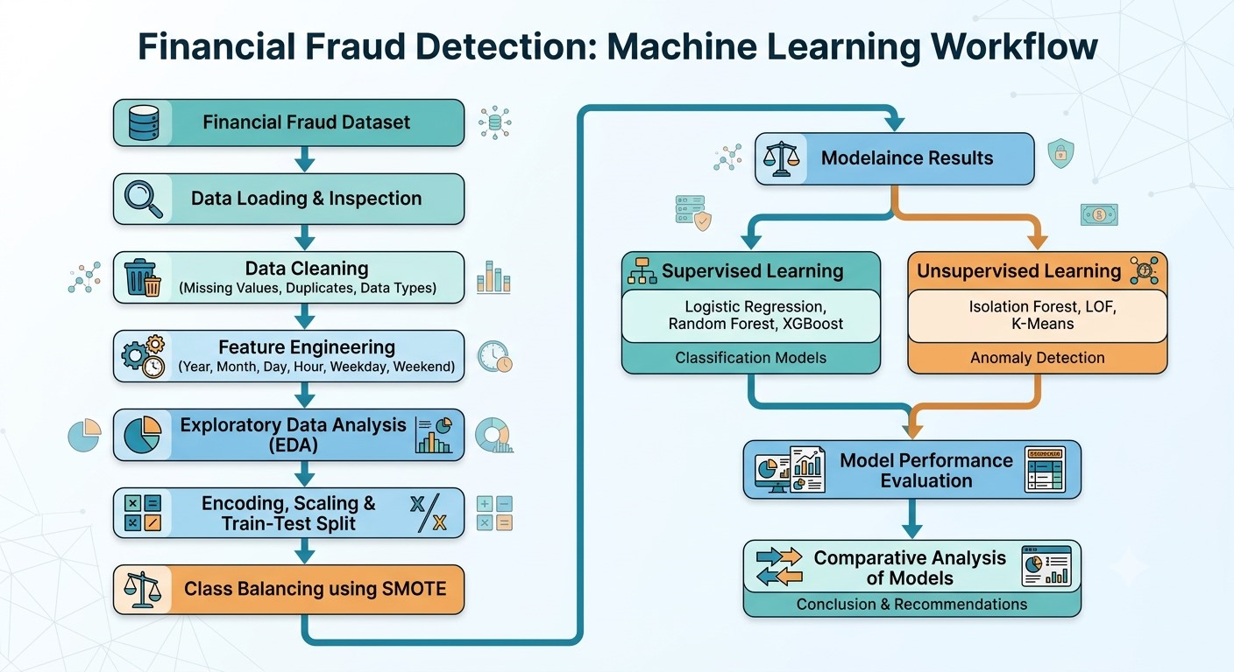

Figure 1: System workflow
The first step was importing the financial transaction data into Python with Pandas. Data quality, data structure, data types and general quality of the dataset were checked before any preprocessing was applied. Temporal information from the transactions' timestamps was then extracted using feature engineering, making the models more sensitive to behavioural patterns associated with the fraudulent transactions. Exploratory Data Analysis (EDA) was used to first become familiar with the characteristics of the dataset and to determine major relationships among variables. After exploration of the data, categorical attributes were encoded, numerical attributes were standardised if needed, and the data was split into a training set (80%) and a test set (20%). The amount of fraudulent transactions was small, so the “Synthetic Minority Oversampling Technique (SMOTE)” was used to normalise the training data prior to training the supervised model [11]. Also, supervised and unsupervised machine learning algorithms were both employed and analysed on the same performance metrics, allowing an objective comparison to be made with regard to their capabilities of detecting fraud.

3.3 Development Environment
The development of the proposed financial fraud detection framework was done with Python in the Jupyter Notebook environment. Python was chosen as it is an open-source programming language that offers a wide range of support for scientific computing, data analysis and machine learning. The project was developed using the Jupyter Notebook as the main development environment [14]. The interactive notebook interface allowed for a step-by-step implementation process: the loading of data, the pre-processing of the data, the exploratory data analysis, the development of the model and the evaluation of the model performance. It also enabled source code, visualisations, tables and explanatory text to be presented all at once, enhancing the ability to reproduce and document the process of implementation.

3.4 Dataset Acquisition and Initial Exploration
The data on financial fraud was imported into the Python environment using the Pandas library. The dataset comprised 10,000 financial transaction records and 10 attributes, which included customer attributes, transaction features and the label for the fraud class. The supervised learning models developed in this study were based on the target variable is_fraud, which was used to label the transaction as legitimate (0) or fraudulent (1).
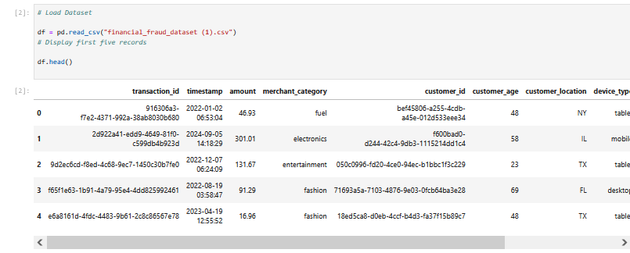

Figure 2: Data Loading
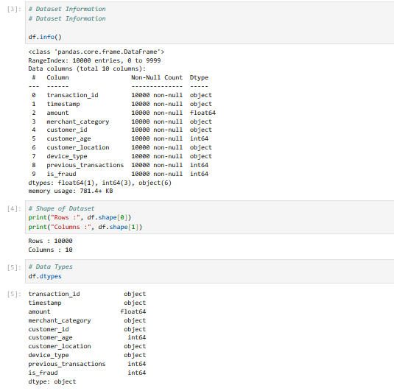

Figure 3: Dataset Information
After loading the data, an initial inspection of the data was done using the head() function to ensure that the data was loaded correctly and to get an overview of the overall structure of the records. The info() function was then called to determine how many observations, attributes, data types, and missing observations there were. The data included numerical data like the number of transactions, the age of the customer, and the number of transactions in the past, as well as categorical data like the merchant category, customer location and device type. The transaction identifier, customer identifier and timestamp were stored as object data types.
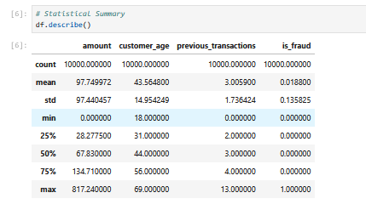

Figure 4: Statistical Summary
The data were then subjected to descriptive statistical analysis by summarising the numerical properties of the data with the describe() function. The statistical summary gave information about the minimum, maximum, mean, median and standard deviation of each numerical attribute. For instance, transactions were between £0.00 and £817.24 and the age of the customer ranged from 18 to 69 years. The average number of transactions that had been made by customers before they made one was around three, showing different levels of customer transaction history.
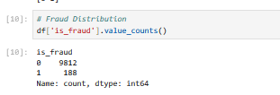

Figure 5: Fraud Distribution
A class distribution was also analysed to ascertain the proportion of legitimate and fraudulent transactions. The analysis of the dataset revealed that there were 9,812 legitimate transactions and 188 fraudulent transactions, which shows that the dataset is imbalanced, with only 1.88% fraudulent transactions in the dataset. This imbalance led to the use of SMOTE techniques to enhance the learning ability of supervised machine learning methods when training the model.

3.5 Data Cleaning and Feature Engineering
One of the most crucial and basic steps in machine learning is data preprocessing, as the quality of the data will directly affect the performance of the machine learning model. The dataset was analysed before building the fraud detection models in order to ensure that there were no data quality issues and that the data was ready for further analysis. The goal for this phase was to enhance the consistency of the data, add more predictive variables and eliminate any irrelevant data that would not aid in fraud classification.

3.5.1 Data Cleaning
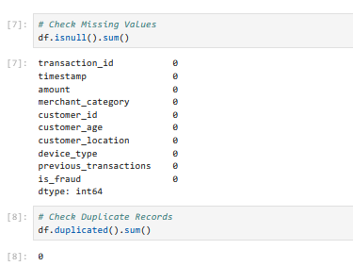

Figure 6: Check Missing and Duplicate Values
The missing values analysis revealed that there were no missing data in the 10 original variables, which means that there was no need to use any imputation techniques. Also, the duplicated() function was used to find the duplicate transaction records. The analysis verified that there were no duplicate observations in the dataset, which guaranteed that each transaction was a different financial transaction.
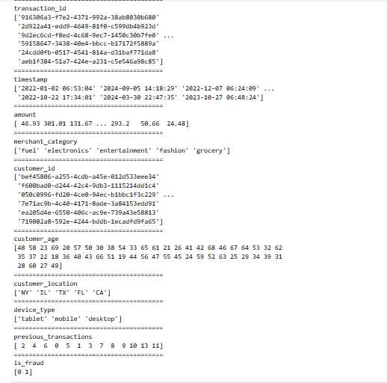

Figure 7: Unique Values
Each attribute's unique values were also analysed to ensure the consistency of the data and for possible anomalies. This inspection verified there were no unexpected entries and that there were valid and consistent categories for categorical variables such as merchant category, customer location and device type.

3.5.2 Feature Engineering
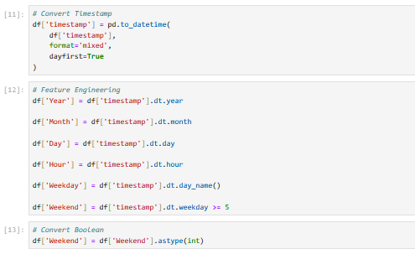

Figure 8: Feature Engineering
The dataset used has a variable named “timestamp”, but not all machine learning algorithms can be directly used to utilise date and time information. Hence, the timestamp attribute was converted to the right datetime format with the Pandas to_datetime() function. This conversion made it possible to extract some temporal features which help enhance the effectiveness of fraud detection. The attribute 'timestamp' was converted into six new variables, which are Year, Month, Day, Hour, Weekday, and Weekend. The Year feature was used to gather the year of the transaction, and Month and Day were used to get the transaction behaviour by season and day. The Hour variable was added as fraudulent transactions often happen during unusual hours, when the activity of monitoring customers is low. Likewise, the Weekend variable allowed for the transaction behaviour to be analysed for transactions made during weekends, where the spending behaviour can be different from the normal working days, and the Weekday feature enabled the analysis of transactions by day of the week.
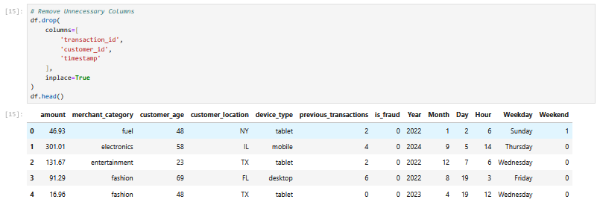

Figure 9: Remove Unnecessary Columns
Three variables were dropped from the dataset after extracting the temporal information, which are transaction_id, customer_id, and the original timestamp column. This information was used as a unique identifier and did not have predictive value. The use of such identifiers would not be beneficial for the classification and would make the model unnecessarily complex.

3.5.3 Prepared Dataset
After feature engineering, the dataset included a mix of numerical, categorical and newly engineered temporal features of customer behaviour and transaction attributes. These altered features gave more information for machine learning algorithms to use to better detect fraudulent transaction behaviours. Also, after completing data cleaning and feature engineering, the data was organised and cleaned, ensuring that it was structured and ready for exploratory data analysis and implementation of machine learning. This step provided a solid basis for developing effective fraud detection models by ensuring that the data was consistent.

3.6 Exploratory Data Analysis (EDA)

3.6.1 Fraud Distribution
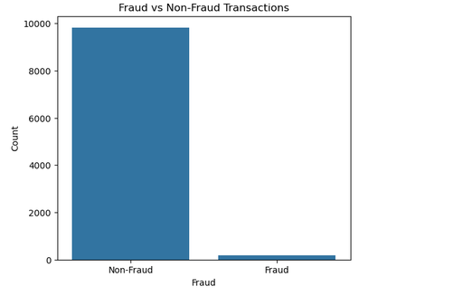

Figure 10: Fraud vs Non-Fraud Transactions
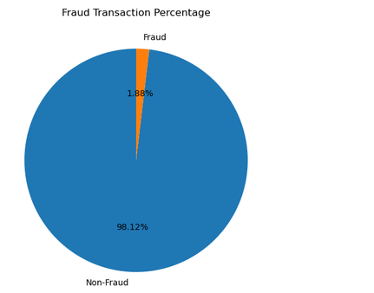

Figure 11: Fraud Transaction Percentage
The above figures (10) and (11) underscore the analysis of the class distribution of the target variable (is_fraud). The count plot revealed that the vast majority of transactions were legitimate, with a small proportion being fraudulent activities. Of the 10,000 financial transactions, 188 were fraudulent (1.88%), while 9,812 were legitimate (98.12%). The financial fraud dataset is very imbalanced because fraudulent activities are relatively rare compared to normal customer transactions. The imbalance revealed a big problem for the machine learning algorithms. Unsupervised models could be biased to predict the majority class and be unable to detect fraudulent transactions if they are not handled properly.

3.6.2 Transaction Amount Analysis
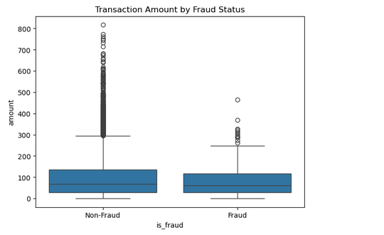

Figure 12: Transaction Amount by Fraud Status
The box and whisker plot was created to compare the amount of each transaction for fraudulent and legitimate transactions. The visualisation revealed a lot of variation in the value of the transactions, with some high-value transactions appearing as outliers. Also, fraudulent transactions had more variation in transaction amounts than legitimate transactions, which means that unusually large financial transactions might be more likely to be fraudulent.

3.6.3 Merchant Category Analysis
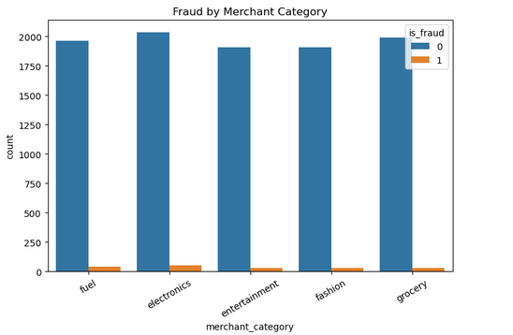

Figure 13: Merchant Category Analysis
Merchant category distribution was analysed to examine if there was any fraud pattern in any specific business categories. The count plot was used to compare the legitimate transactions and the fraudulent transactions for the different merchant categories, such as grocery, fuel, electronics, entertainment and fashion. While legitimate transactions accounted for each category, there were some minor differences in the fraudulent transaction rates by merchant type. This implies that the behaviour of buying may vary across merchant categories and that this variable can provide valuable information for the predictive task when training the model.

3.6.4 Device Type Analysis
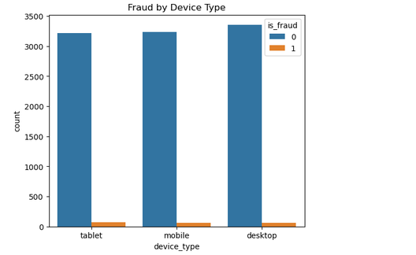

Figure 14: Fraud by Device Type
Here, the researcher uses a grouped count plot to compare the relationship between device type and fraudulent activity. The transactions were classified based on the origin of the device (desktop, mobile device and tablet). The visualisation showed that every single platform underscores fraud. However, there were some minor variations in fraud incidence rates across devices, indicating that the way customers access the device could offer further behavioural signals that could be valuable for fraud detection models.

3.6.5 Customer Location Analysis
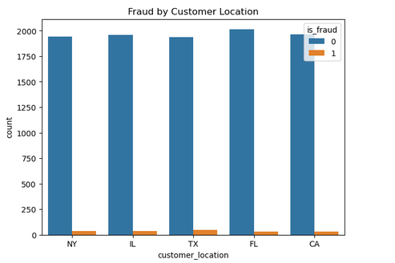

Figure 15: Fraud by Customer Location
The locations of customer transactions were also analysed to find out whether there was any geographical pattern in the data. Transactions were made from multiple locations such as California (CA), Florida (FL), Illinois (IL), New York (NY) and Texas (TX). The results revealed that the number of legitimate transactions greatly exceeded the number of fraudulent transactions at all locations. While no state had remarkably high rates of fraud, geographical information can be useful as it can help identify variations in customer behaviour across regions based on spending patterns and transaction frequency.

3.6.6 Fraud by Hour of Day
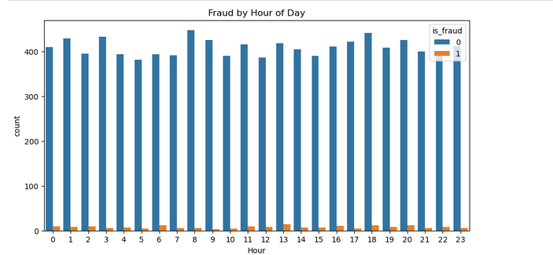

Figure 16: Fraud by Hour of Day
The engineered Hour feature allowed the investigation of transaction behaviour throughout the day. The number of frauds occurring each hour was investigated using a count plot. The analysis revealed that transactions occurred across the entire day, and the fraudulent activities were not only spread across the day, but also across multiple time intervals as well. This observation justifies that temporal attributes can be used in conjunction with the other predictive attributes to detect unusual transaction timing in the customer's behaviour.

3.6.7 Fraud by Weekday
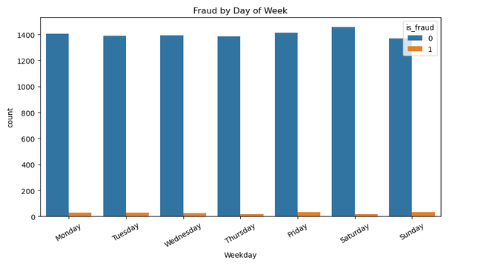

Figure 17: Fraud by Weekday
The engineered variable Weekday was used to further analyse transaction activity by day of the week. It was seen that there were both genuine and fraudulent transactions on each day of the week. While a specific trend was not identified during the week, the addition of weekday data can enable machine learning algorithms to detect subtle changes in behaviour that might not be apparent when looking at the data manually.

3.6.8 Correlation Analysis
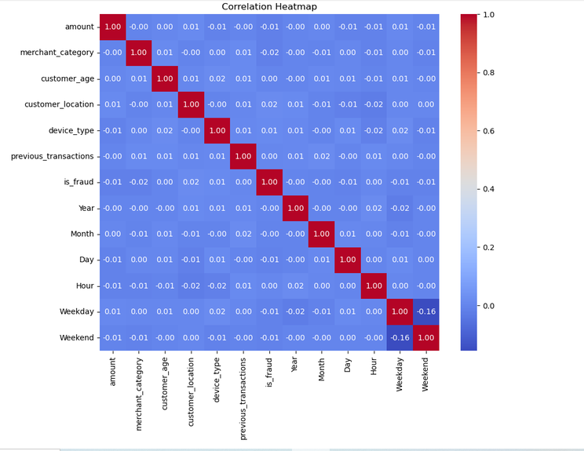

Figure 18: Correlation Analysis
To explore correlations between numerical and encoded categorical variables, a correlation heatmap was created. The attributes were categorical, and the first step in conducting correlation analysis was to convert them into numerical values via Label Encoding. The heatmap showed that there was not a high degree of multicollinearity in the dataset, with most pairs of variables showing relatively low correlation. This is beneficial since some machine learning algorithms could be negatively impacted by highly correlated variables, which carry redundant information. The low correlation values indicate that no one feature is correlated with another, meaning that each one provides distinct information for fraud detection. Also, the target variable (is_fraud) had weak linear relationships with individual predictors. This result suggests that fraud detection is a combination of multiple features, and not a single dominant one. Thus, using multiple supervised and unsupervised machine learning algorithms is an appropriate method to detect these complicated behavioural patterns.

3.7 Data Pre-processing for Machine Learning
The dataset was preprocessed before applying the machine learning algorithms to ensure compatibility with the chosen models and enhance prediction accuracy. The prepared dataset was subjected to various preprocessing techniques to align with the selected machine learning models and optimise prediction results. The data was a combination of numerical and categorical data, so suitable preprocessing techniques were used to ensure the data was suitable for machine learning.
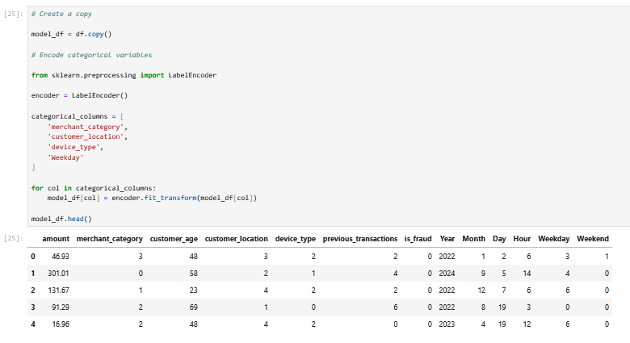

Figure 19: Encoding
Figure (19) underscore categorical variables were encoded as the first preprocessing step. The merchant_category, customer_location, device_type, and Weekday attributes had text values that were not suitable for machine learning algorithms. For this reason, the LabelEncoder function of the Scikit-learn library was used to encode each categorical value with a numerical value without losing the class labels.
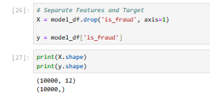

Figure 20: Separate Features and Target
The above figure (20) states that the encoded data was split into predictor variables and the target variable. The predictor dataset (X) included 12 features describing customer characteristics, transaction information, and engineered temporal features, while the target variable (y) was the fraud label, with legitimate transactions labelled as 0 and fraudulent transactions labelled as 1.
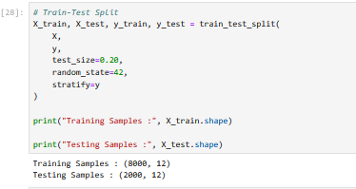

Figure 21: Train-Test Split
The upper figure (21) shows that the dataset was split into a training and testing set with the train_test_split() function to evaluate the models objectively. It was decided to use an 80:20 ratio, with 8,000 training records and 2,000 testing records. In both datasets, stratified sampling was used to maintain the original distribution of fraud cases.
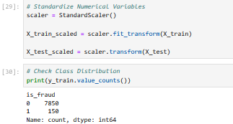

Figure 22: Standardise Numerical Variables and Check Class Distribution
Also, the researcher used the StandardScaler algorithm for feature scaling. All numerical variables were normalised to have a mean of 0 and a variance of 1. Standardisation was important for distance-based algorithms, which are Logistic Regression, Local Outlier Factor and K-Means clustering, to ensure that variables measured on a larger, numerical scale did not dominate the learning of the models. The training data was analysed, and the result showed a very imbalanced dataset with just 150 transactions being fraudulent and 7,850 being legitimate transactions.
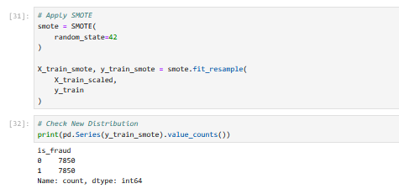

Figure 23: Apply SMOTE
To overcome this problem, the “Synthetic Minority Oversampling Technique (SMOTE)” was used only for the training set. The synthetic fraud samples were created by SMOTE between the existing minority class observations to create a balanced dataset of legitimate transactions (7,850) and fraud transactions (7,850). Only training data was used for SMOTE, so it avoided data leakage and allowed for the supervised algorithms to learn fraud patterns more effectively.
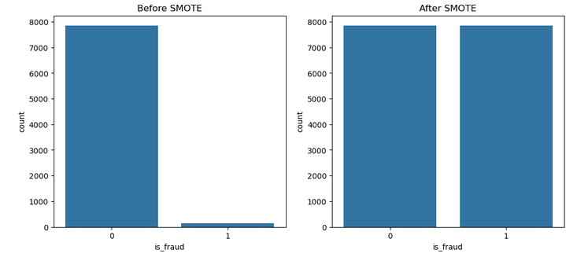

Figure 24: Before and after SMOTE
The final pre-processing phase yielded a balanced, clean and well-structured dataset that could be used to develop supervised and unsupervised machine learning models.

3.8 Supervised Machine Learning Models
The three supervised machine learning models implemented for the classification of financial transactions were “Logistic Regression, Random Forest and XGBoost”. The algorithms were chosen as they represent various classification concepts and as they are commonly used in financial fraud detection research.
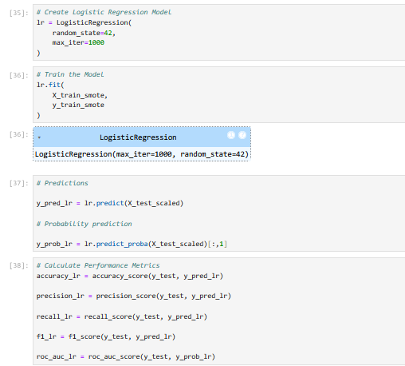

Figure 25: Train Logistic Regression
The above figure (235) states that the researcher uses Logistic Regression as a baseline classification model because it is simple and easy to interpret. The training dataset used for the model was the SMOTE-balanced training set, and the model was optimised for a maximum of 1000 iterations to achieve convergence. Once the model was trained, predictions were made on the unseen testing dataset, and the performance of the model was assessed based on the accuracy, precision, recall, F1-score, ROC-AUC, confusion matrix, and classification report.
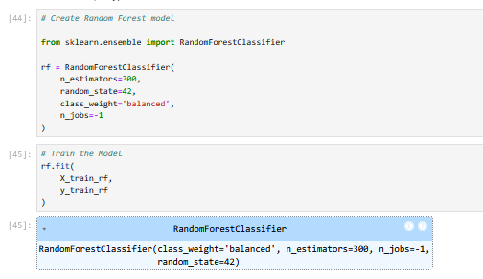

Figure 26: Train Random Forest
Also, Figure 26 states that the Random Forest was developed with 300 decision trees. To minimise the bias towards the majority class, the model used bootstrap aggregation and balanced class weighting [6]. After training, the model made predictions for the testing set and gave out the values of feature importance, which shows the relative contribution of each predictor variable.
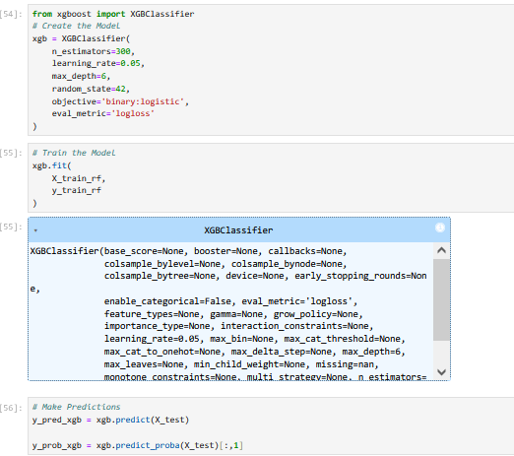

Figure 27: Train XGBoost Classifier
The third supervised model used was XGBoost, an advanced gradient boosting model which seeks to enhance the predictive accuracy of the model by learning the tree sequentially [7]. The model was set up with 300 estimators, a learning rate of 0.05 and a maximum tree depth of 6. Also, the use of multiple supervised algorithms allowed a detailed comparison of the various classification methods and highlighted the difficulties of identifying rare fraudulent transactions in financial datasets with a high degree of imbalance.

3.9 Unsupervised Machine Learning Models
Three unsupervised machine learning algorithms were also implemented to detect anomalous transaction behaviour without the use of fraud labels during model training, complementing the supervised learning techniques. Such algorithms are especially useful in real-world financial systems as new fraud patterns typically occur before labelled training data has been collected.
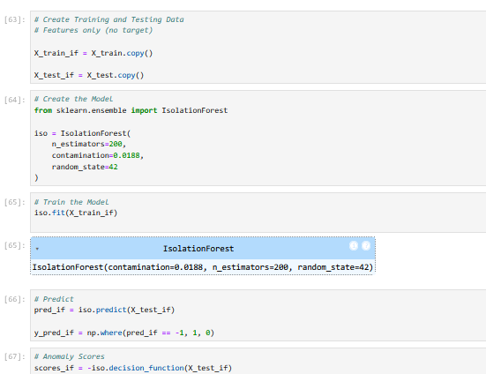

Figure 28: Train Isolation Forest
The aforementioned figure (28) shows that the researcher developed Isolation Forest, which was an anomaly detection algorithm that randomly partitions the dataset to isolate the anomalous observations. The model was trained with the predictor variables, and the proportion of fraudulent transactions in the data was considered to be 0.0188. Predicted transactions which were deemed anomalies were classified as fraudulent transactions. The classification metrics used for the evaluation of model performance were the same as those used for the supervised models.
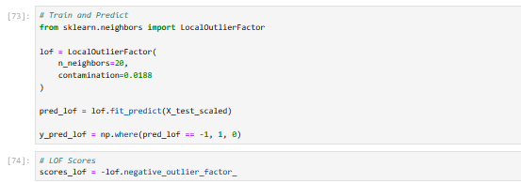

Figure 29: Train Local Outlier Factor (LOF)
The second unsupervised model was Local Outlier Factor (LOF), which detects anomalies based on the local density of each observation compared to its neighbours' transactions. Transactions with significantly reduced local density were considered fraud cases. The model used 20 neighbouring observations, and the anomaly scores were then compared by confusion matrices, classification reports and ROC-AUC values.
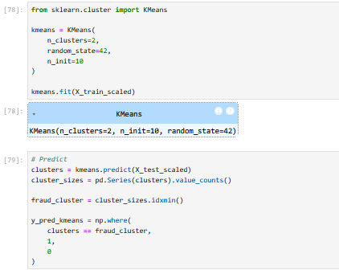

Figure 30: Train K-Means Clustering
The above figure (30) shows that the researcher uses K-Means clustering, which groups the observations into clusters based on the similarity of the features. The transaction groups were grouped into two clusters to reflect the normal and abnormal transaction groups. The smaller cluster was considered to be the most likely to be fraudulent and labelled the fraud cluster. Anomaly scores were also computed based on Euclidean distances from the cluster centroids for the evaluation of ROC-AUCs. These three methods are all unsupervised techniques, so they offer an alternative method for fraud detection without labelled training data. They were then compared to the supervised algorithms in order to find the best way to detect fraudulent financial transactions.

Evaluation and Results

4.1 Related Works
Supervised and unsupervised machine learning methods have been widely explored for financial fraud detection. There have been several studies that have proven the superiority of machine learning over traditional fraud detection rules, as the machine learning models can learn complex transaction patterns and adjust to the changing fraudulent behaviour. But the performance of the models is sensitive to the characteristics of the dataset, feature engineering and class imbalance. Chen and Guestrin [1] showed that XGBoost is an effective gradient boosting algorithm that is highly accurate and has low computational costs. XGBoost performed best in this project with an accuracy of 92.75%, but it did not get cogent precision, recall and F1-score for detecting fraudulent transactions correctly, resulting in 0 for each. This means that the high accuracy is not sufficient to ensure good fraud detection in highly imbalanced datasets. Also, Breiman [14] reported that Random Forest performs well in classification performance with ensemble learning and prevents overfitting. Like XGBoost, Random Forest was good at the overall accuracy (95.65%) but had low accuracy only for the minority class in this study, meaning that it was not very effective in detecting minority fraud cases. The performance of Isolation Forest was more consistent with that of Liu et al. [2], who specifically proposed it for the task of anomaly detection. Isolation Forest was able to detect a large number of fraudulent transactions without the need to have labelled training data and recorded one of the highest overall accuracies of 96.15%. Similarly, LOF [17] and K-Means clustering [18] were able to detect some anomalous transactions, but with relatively low precision and F1-scores, due to the difficulties of detecting fraud in an unsupervised way. Recent research suggests hybrid machine learning models which integrate supervised and unsupervised learning. Chapwanya and Gorejena [12] and Monteiro et al. [11] showed that incorporating anomaly detection with supervised classification yields better detection of known and new fraud patterns. This is confirmed by the results of the present study, which implies that future studies and research should focus on hybrid systems to further improve the performance of fraud detection and minimise false classification.

4.2 Evaluation Methodology
The researcher uses a consistent experimental methodology to evaluate the developed financial fraud detection framework to enable comparison of all machine learning algorithms. The dataset was split into 80% training data and 20% testing data, where the training data was used to develop the model and the testing data was used to test the model. Also, SMOTE was only used for the training data because of the extreme class imbalance (1.88% fraudulent transactions) to boost the learning power of supervised models and the testing data was not used to preserve the real-world condition. The same pipeline was applied to Logistic Regression, Random Forest, XGBoost, Isolation Forest, Local Outlier Factor (LOF) and K-Means. The assessment of the models was done through Accuracy, Precision, Recall, F1-score and ROC-AUC to provide a comprehensive comparison of each model's fraud detection capability.

4.3 Experimental Results

4.3.1 Logistic Regression
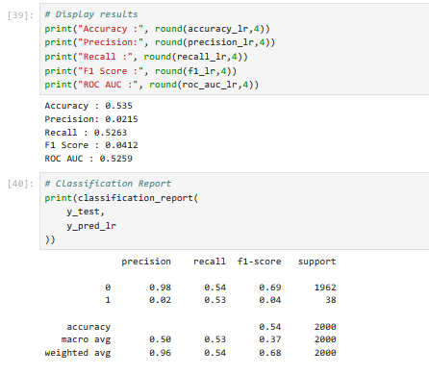

Figure 31: Classification Report of Logistic Regression (LR)
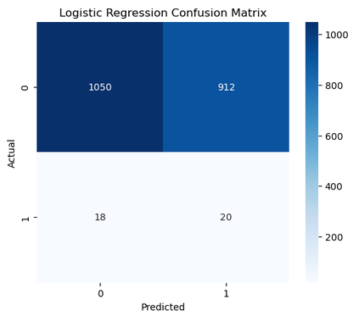

Figure 32: Confusion Matrix of LR
Logistic Regression is used as the baseline supervised learning model in order to assess the binary fraud classification performance. A SMOTE-balanced training set was used to train the model, and the model was tested on previously unseen transactions. From the confusion matrix, it is observed that the model was able to detect more than 50% of the fraudulent transactions, but also misclassified numerous legitimate transactions as fraudulent ones. The high number of false positives was due to the model's preference for detecting fraud after training with the balanced dataset. Logistic Regression achieved an accuracy of 53.50%, precision of 2.15%, recall of 52.63%, F1-score of 0.0412, and ROC-AUC of 0.5259.
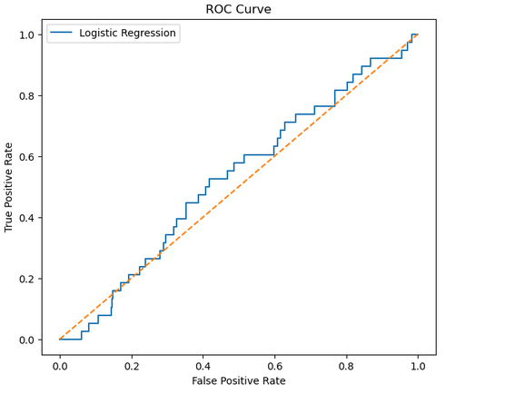

Figure 33: ROC curve of LR
The ROC curve shows the model was not much better than random classification. It had the highest recall among the supervised models, but its very low precision and F1 scores make it not suitable for practical financial fraud detection because of its high number of false alarms.

4.3.2 Random Forest
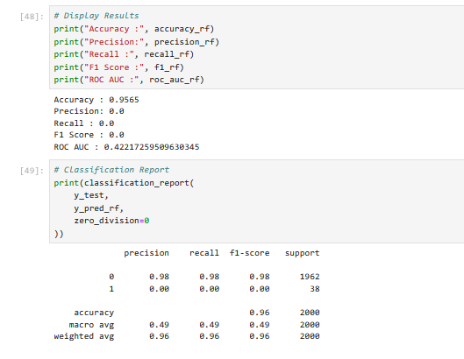

Figure 34: Classification Report Of Random Forest (RF)
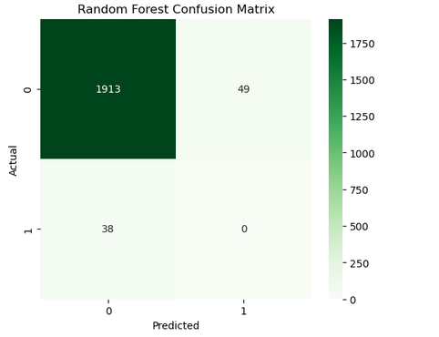

Figure 35: Confusion Matrix of RF
Random Forest was used as an ensemble learning method, having multiple decision trees trained on the SMOTE-balanced dataset. The model was tested on an unseen test set to determine its ability to detect fraud. The confusion matrix demonstrates that the Random Forest model was able to accurately classify nearly all of the legitimate transactions, but was unable to detect any fraudulent transactions. Therefore, every instance of fraud was recorded as being genuine. The model had an accuracy of 95.65%, but failed to reach any precision, recall or F1 score due to their value being 0.0000, with a ROC-AUC score of 0.4222, meaning that the model was not well-discriminating between fraudulent and legitimate transactions.
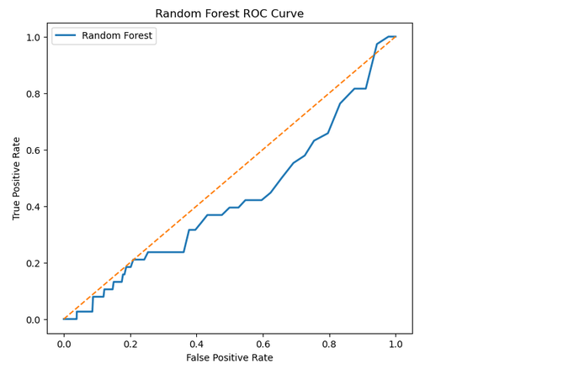
Figure 36: ROC curve of RF
Although the accuracy of the model is high, the ROC curve shows that the model has poor discrimination power for fraudulent transactions.
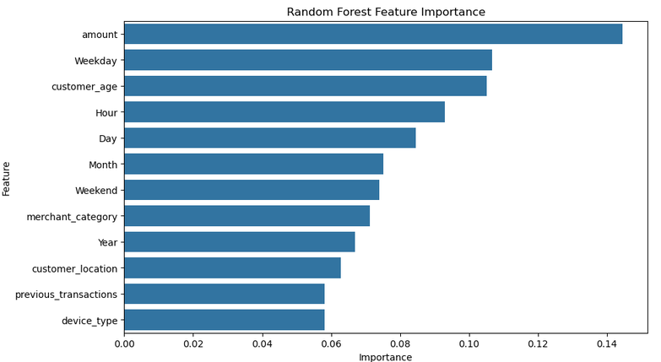

Figure 37: Feature Importance of Random Forest
Transaction amount, weekday, customer age and hour were the most important predictors, as identified through feature importance analysis. The model was highly skewed towards the majority class and showed high accuracy, which is not enough to assess the performance of fraud detection when the dataset is highly imbalanced.

4.3.3 XGBoost
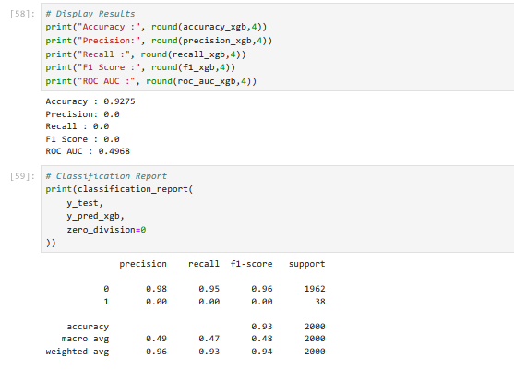

Figure 38: Model evaluation of XGBoost
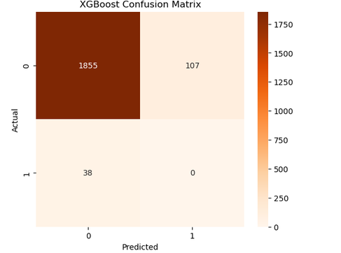

Figure 39: Confusion matrix XGBoost
XGBoost was chosen as the third supervised learning algorithm because it has the ability to create accurate predictive models using gradient boosting. The training set was SMOTE-balanced, and the unseen testing set was used to evaluate the model. As seen in the confusion matrix, XGBoost classified all the legitimate transactions correctly and did not detect any fraudulent transactions. The accuracy of the model was 92.75%, but the precision, recall and F1-score were all at 0.0000, and the ROC-AUC score was 0.4968, which is very close to the performance of a random classifier.
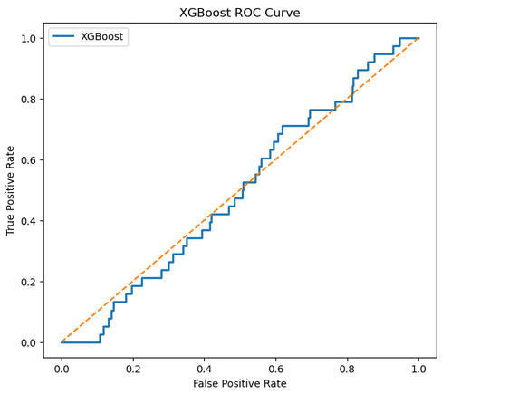

Figure 40: ROC curve of XGBoost
The ROC curve also demonstrates that the model is not very effective in separating fraudulent transactions from legitimate transactions.
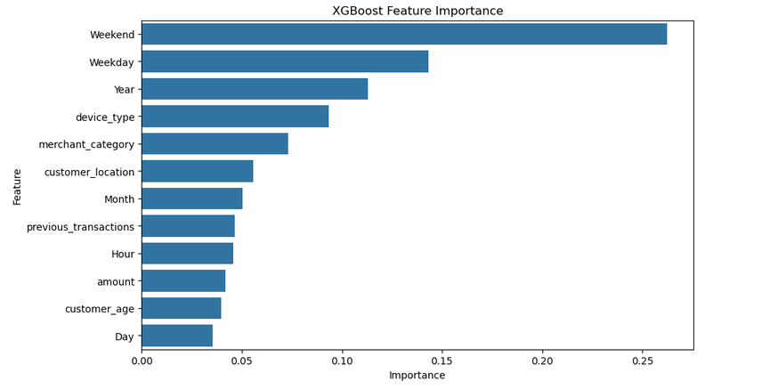

Figure 41: XGBoost Feature Importance
The feature importance analysis identified that some of the transaction-related variables were important in predicting the model. However, these features were not enough to improve fraud detection in the highly imbalanced dataset, indicating that further feature engineering or parameter tuning should be done to further boost the performance of XGBoost.

4.3.4 Isolation Forest
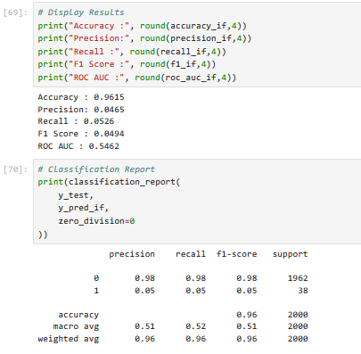

Figure 42: Classification Report of Isolation Forest
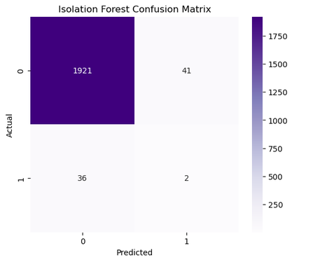

Figure 43: Isolation Forest Confusion Matrix
The above figure (43) underscores that the researcher chose Isolation Forest as the main unsupervised algorithm for anomaly detection because it detects anomalies without the need for labelled training data. The model identifies unusual observations according to their features, which means it can be used to find new types of fraud. The confusion matrix indicates that the model was able to accurately identify the majority of legitimate transactions and a limited number of fraudulent transactions. Isolation Forest outperformed the supervised models in fraudulent transaction detection with 96.15% accuracy, 4.65% precision, 5.26% recall, 0.0494 F1-score and 0.5462 ROC-AUC.
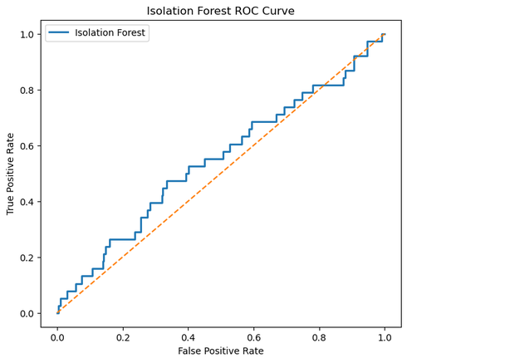

Figure 44: Isolation Forest ROC Curve
The ROC curve shows that Logistic Regression, Random Forest, and XGBoost have inferior discrimination between fraud and legitimate transactions when compared to Isolation Forest. The results showed that while the precision and recall were not particularly high, the performance of Isolation Forest in anomaly detection suggests that it could be more useful in a hybrid fraud detection system using supervised learning.

4.3.5 Local Outlier Factor (LOF)
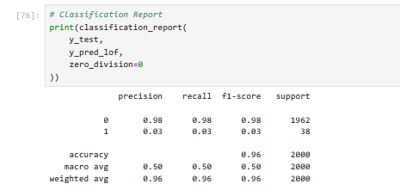
Figure 45: Classification Report of Local Outlier Factor
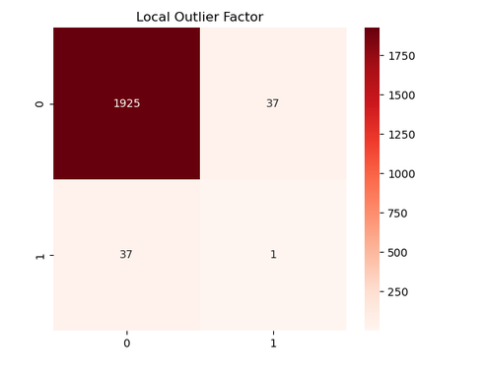

Figure 46: Confusion matrix
Local Outlier Factor (LOF) is another unsupervised anomaly detection algorithm that was applied to detect fraudulent transactions based on the differences in local data density. Observations with significantly lower densities than those around them were deemed to be potential anomalies. It can be seen from the confusion matrix that LOF was able to correctly classify nearly all of the legitimate transactions and was able to detect the fraudulent transactions with a very small number of cases. The overall accuracy of the model (96.30%) was the best amongst all the evaluated algorithms. However, its precision (2.63%), recall (2.63%), F1-score (0.0263), and ROC-AUC (0.5236) indicate limited fraud detection capability. The results confirm that LOF is able to model normal transaction behaviour well, but is not very good at capturing subtle fraud patterns in highly imbalanced datasets. Hence, LOF is better suited to be used as an additional anomaly detection method in a hybrid fraud detection system than as a standalone fraud detection method.

4.3.6 K-Means Clustering
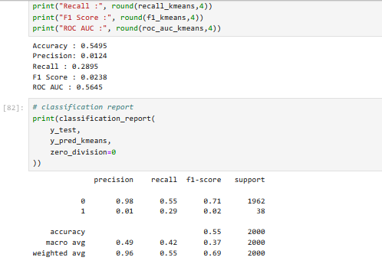

Figure 47: Classification report of K-Means Clustering
To examine if an unsupervised clustering technique could successfully separate fraudulent and legitimate transactions by their similarity in transaction attributes, K-Means clustering was used. The algorithm was able to cluster the transactions into two groups; one smaller group was believed to be possibly fraudulent. The model was trained with an accuracy of 54.95%, which was significantly lower than the other unsupervised algorithms. There was a larger proportion of detected fraudulent transactions with a recall of 28.95%. The precision was still very low (1.24%), and the F1 score was 0.0238. Although the classification accuracy of K-Means is lower, it achieved the highest ROC-AUC score (0.5645) when compared to all the algorithms evaluated, which means that it has comparatively better discrimination between fraudulent and legitimate transactions for different thresholds. The outcome indicates that K-Means is capable of discovering clusters of suspicious transactions, but with a high number of false positives. Thus, while it cannot be used as a standalone fraud detection model, it can be used as a helpful complementary approach in a hybrid fraud detection approach, in combination with supervised or anomaly detection models.

4.4 Comparative Analysis
The comparative analysis of the six machine learning algorithms shows that they each had its own advantages and disadvantages in the context of financial fraud detection. Figure 48 presents a summary of all models' performance with respect to Accuracy, Precision, Recall, F1-score and ROC-AUC, which are used to compare the ability of all models to detect fraud.
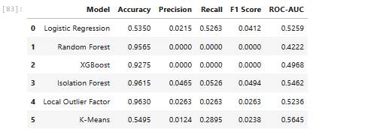

Figure 48: Comparison analysis
The accuracy of the algorithms reveals that Local Outlier Factor (96.30%) performed better than the other two algorithms, followed by Isolation Forest (96.15%) and Random Forest (95.65%). These high accuracies should be taken with another evalution metrices performances, as the dataset was extremely skewed, with fraudulent transactions being only 1.88% of the total number of transactions observed. As a result, most models that were able to classify most transactions as legitimate naturally had high accuracy, but had poor detection rates for fraud. Logistic Regression had the best recall (52.63%), correctly recognising more than half of the fraudulent transactions. Its accuracy (2.15%) was still very poor, however, which meant that a lot of valid transactions were being flagged as fraud. On the other hand, Random Forest and XGBoost had high overall accuracy but had no precision, recall or F1-Score as they were not able to detect any fraudulent transactions. The results show that the overall accuracy is not a suitable performance measure for highly imbalanced fraud detection problems [17]. The unsupervised models gave more well-balanced results. Isolation Forest obtained the highest precision (4.65%) and F1-score (0.0494), while the highest ROC-AUC (0.5645) was obtained by K-Means, which showed comparatively cogent discrimination between legitimate and fraudulent transactions. The accuracy was also high for Local Outlier Factor, but its ability to detect fraud was restricted due to its low recall rate. It can be stated that the evaluation shows that none of the algorithms performed better on all the performance measures. Unsupervised models demonstrated higher performance when it came to detecting anomalous behaviour, while supervised models performed better in terms of classification accuracy. The results indicate that a hybrid machine learning approach combining supervised classification with anomaly detection could boost financial fraud detection systems in the future to achieve better fraud detection accuracy while decreasing false classification rates.

4.5 Strengths and Limitations of Developed Framework
The financial fraud detection framework developed has various strengths. Firstly, it uses supervised and unsupervised machine learning algorithms, allowing for a full comparison between various fraud detection methods using a common experimental setup. Secondly, all the models used the same pre-processing pipeline, which included “data cleaning, feature engineering, categorical encoding, feature scaling, and splitting the data”. This provided consistency in implementing the model and enabled a fair comparison of the performance of the model [26]. Furthermore, to overcome the high class imbalance issue in the training set, synthetic fraud samples were created using SMOTE to help the supervised models better learn the characteristics of the minority classes. In addition, several metrics were used to assess the model performance, including “accuracy, precision, recall, F1 score, and ROC-AUC”, which are more accurate than accuracy to measure the model's ability to detect fraud.
Also, the framework has a number of weaknesses. There were only 10,000 transactions in the dataset, and 188 were classified as fraudulent (1.88%), making it a highly imbalanced problem for classification. While SMOTE helped to balance the class distribution in training, the synthetic samples may not accurately reflect real-world fraud patterns and may lead to bias in the learning process. Moreover, there was limited information about the customer and the transaction, which limited the behavioural information available for model learning. Additional transaction characteristics, including transaction frequency, merchant risk scores, customer spending patterns, and geographic movement, could deliver further enhancements to predictive performance. Also, the experimental results indicated that the accuracy was high, but the algorithms did not detect the fraudulent transactions, emphasising the importance of considering other metrics for evaluating algorithms[19]. The unsupervised models were able to detect some anomalies, but the precision and recall were still fairly low. Future studies could thus explore hybrid machine learning approaches, more sophisticated feature engineering and larger real-world financial datasets to enhance fraud detection effectiveness and minimise false positive predictions.

4.6 Chapter Summary
The effectiveness of the proposed financial fraud detection framework was tested on supervised and unsupervised machine learning algorithms in this chapter. The experimental results showed that the performance of the model was significantly different across different evaluation methods. Random Forest and Local Outlier Factor had high overall accuracy, whereas Logistic Regression had the highest Recall, and K-Means had the highest ROC-AUC score. Another key point that came from the evaluation was the difficulty in dealing with financial datasets that are extremely imbalanced, and the fact that accuracy is not an appropriate measure for fraud detection.

Conclusion
In this dissertation, the researcher compares the supervised and unsupervised machine learning algorithms for financial fraud detection on a financial transaction dataset of 10,000 data records. The main objective of the study was to assess the performance of various machine learning methods to detect fraudulent financial transactions and to explore how severe class imbalance affects the performance of these models. For this goal, a machine learning system was built and deployed in Python via the Jupyter Notebook environment. The framework consisted of “data acquisition, data preprocessing, feature engineering, exploratory data analysis, model development, and performance evaluation by multiple classification metrics”. The project successfully fulfilled the research goals with the application of the six machine learning algorithms, three of which were supervised models (“Logistic Regression, Random Forest and XGBoost”) and the other three were unsupervised models (“Isolation Forest, Local Outlier Factor and K-Means clustering”). All models were trained and evaluated under the same experimental conditions with a consistent preprocessing pipeline that consisted of “data cleaning, categorical encoding, feature engineering, dataset splitting and Synthetic Minority Oversampling Technique (SMOTE)”. This allowed them to be fairly and accurately compared. The experimental results showed that there was no algorithm which could be consistently better than the others in all the evaluation metrics. Random Forest, XGBoost, Local Outlier Factor and Isolation Forest were able to provide high overall classification accuracy, but were not effective at capturing the minority fraud class due to the extreme imbalanced nature of the data. Logistic Regression had the highest recall, meaning it was able to identify the most fraudulent transactions, while among the unsupervised methods, Isolation Forest had the best performance to detect anomalies. K-Means clustering had the best ROC-AUC performance and thus the best discrimination between normal and anomalous transactions. The results suggest that accuracy of classification is not a sufficient measure to assess fraud detection systems. Rather, in highly imbalanced datasets, precision, recall, F1-score and ROC-AUC are more comprehensive measures of a model's performance. Through the comparative analysis it was further shown that supervised learning algorithms are useful for the classification of known transaction patterns, while unsupervised anomaly detection techniques are better for detecting previously unknown fraudulent transactions. Based on this, the study suggests that hybrid machine learning models combining supervised classification and anomaly detection techniques can be expected to yield more accurate and reliable financial fraud detection systems. The project has accomplished its overall objective and has been able to offer valuable insights into how machine learning can be applied to detect financial fraud and a solid basis for further research in this field.

5.1 Future Work
The financial fraud detection framework developed in this study has met the aims of the study, but there are some areas where it could be further developed. The proposed framework needs to be assessed in larger real-world financial transaction datasets from banks or payment service providers in future. More extensive and varied datasets would help machine learning models to learn more about fraud patterns and generalise to unobserved transactions. Advanced deep learning methods such as Artificial Neural Networks (ANN), Long Short-Term Memory (LSTM) networks, Autoencoders, and Graph Neural Networks (GNNs) are further research opportunities that could be explored. These methods can discover complicated non-linear relationships and temporal transaction patterns which can enhance the accuracy of fraud detection [18]. Hybrid supervised and unsupervised approaches combining machine learning classification with anomaly detection could also be investigated in future research. The use of algorithms like Isolation Forest in conjunction with ensemble classifiers can lead to more accurate identification of known and unknown fraudulent activities and fewer false positive predictions. Greater improvements can be made with better feature engineering using the use of customer behavioural data, transaction frequency, merchant risk scores, geographical movement patterns and device fingerprint data [19]. Furthermore, future research could explore other methods of handling imbalances, like ADASYN and cost-sensitive learning, as well as explore extensive hyperparameter optimisation. Also, the integration of “explainable artificial intelligence (XAI) methods, like SHAP or LIME”, would enhance model transparency, enabling financial institutions to comprehend and justify the automated fraud detection choices, which can aid in regulatory compliance and foster consumer trust.

5.2 Reflection
This project has greatly improved my technical knowledge as well as research skills. In the whole project, I have learned how to implement a full machine learning workflow, from “data acquisition and preprocessing to feature engineering and exploratory data analysis”, to the development of the models, their evaluation and interpretation of the experimental results. This project helped me understand the supervised and unsupervised machine learning algorithms, and how to choose the right evaluation metrics for an extremely imbalanced dataset. The most important lesson was that the high classification accuracy does not necessarily mean that the model is performing well. At first glance it seemed that Random Forest and XGBoost were the best models due to the high accuracy scores they achieved. A more detailed examination of the models using the metrics of precision, recall, f1 score and ROC-AUC showed that these models did not perform well at detecting fraudulent transactions. This experience highlighted the need to choose the metrics used to evaluate the system to be those that align with the real-world tasks of fraud detection, and not just the overall accuracy. While implementing, some obstacles were faced. The supervised models were not able to learn well due to the overwhelming number of valid transactions compared to the number of fraudulent ones. In addition, choosing appropriate preprocessing methods, optimizing model parameters and analysing the comparative performance of the various algorithms was a complex process that involved lots of experimentation and critical analysis. The difficulties made me think about how to solve problems and helped me better understand the implementation of practical machine learning. For future, I would spend more time on the hyperparameter tuning, feature engineering and trying out different machine learning models. I would also want to have access to bigger real-world financial datasets that provide more behavioural data and a wider variety of fraud patterns. Also, I would undertake research on hybrid learning methods and on techniques of Explainable Artificial Intelligence to boost the accuracy of detection and the transparency of the models. It can be concluded that this project has been successful in meeting its aims and has offered beneficial academic and practical experiences in machine learning and financial fraud detection. The skills and information gained during this research have enhanced my ability to carry out my own research as well as to apply data and concepts to real-world problems. The project also has laid the groundwork for future research in artificial intelligence, cybersecurity, and financial data analysis.

References
[1] Chen, T. and Guestrin, C., 2016, August. Xgboost: A scalable tree boosting system. In Proceedings of the 22nd acm sigkdd international conference on knowledge discovery and data mining (pp. 785-794). https://dl.acm.org/doi/abs/10.1145/2939672.2939785
[2] Liu, F.T., Ting, K.M. and Zhou, Z.H., 2008, December. Isolation forest. In 2008 eighth ieee international conference on data mining (pp. 413-422). IEEE. https://ieeexplore.ieee.org/abstract/document/4781136/
[3] Hernandez Aros, L., Bustamante Molano, L.X., Gutierrez-Portela, F., Moreno Hernandez, J.J. and Rodríguez Barrero, M.S., 2024. Financial fraud detection through the application of machine learning techniques: a literature review. Humanities and Social Sciences Communications, 11(1), pp.1-22. https://www.nature.com/articles/s41599-024-03606-0
[4] Ngai, E.W., Hu, Y., Wong, Y.H., Chen, Y. and Sun, X., 2011. The application of data mining techniques in financial fraud detection: A classification framework and an academic review of literature. Decision support systems, 50(3), pp.559-569. https://www.sciencedirect.com/science/article/pii/S0167923610001302
[5] Phua, C., Lee, V., Smith, K. and Gayler, R., 2010. A comprehensive survey of data mining-based fraud detection research. arXiv preprint arXiv:1009.6119. https://arxiv.org/abs/1009.6119
[6] UK Government, 2018. Data Protection Act 2018. London: The Stationery Office.
[7] European Parliament and Council, 2016. Regulation (EU) 2016/679 (General Data Protection Regulation – GDPR). Official Journal of the European Union.
[8] Ashtiani, M.N. and Raahemi, B., 2021. Intelligent fraud detection in financial statements using machine learning and data mining: a systematic literature review. Ieee Access, 10, pp.72504-72525. https://ieeexplore.ieee.org/abstract/document/9481913/
[9] Fang, W., Li, X., Zhou, P., Yan, J., Jiang, D. and Zhou, T., 2021. Deep learning anti-fraud model for internet loan: Where we are going. Ieee Access, 9, pp.9777-9784. https://ieeexplore.ieee.org/abstract/document/9320567/
[10] Nicholls, J., Kuppa, A. and Le-Khac, N.A., 2021. Financial cybercrime: A comprehensive survey of deep learning approaches to tackle the evolving financial crime landscape. Ieee Access, 9, pp.163965-163986. https://ieeexplore.ieee.org/abstract/document/9642993/
[11] Monteiro, T.V.P., Castor, G.J.B.C., Castillo Correa, C.G., Arias, H.R.C., Ñaupari Huatuco, D.Z. and Molina Rodriguez, Y.P., 2025. A Hybrid Machine Learning Framework for Electricity Fraud Detection: Integrating Isolation Forest and XGBoost for Real-World Utility Data. Energies, 18(23), p.6249. https://www.mdpi.com/1996-1073/18/23/6249
[12] Chapwanya, N. and Gorejena, K.N., 2025. Hybrid unsupervised machine learning for insurance fraud detection: PCA-XGBoost-LOF and isolation forest. Journal of Information Systems and Informatics, 7(1), pp.941-959. https://pdfs.semanticscholar.org/5018/9881b60178312b05205b3c3d00609d06b48a.pdf
[13] Gopalakrishnan, V., 2026. SilIF: Silhouette-Augmented Isolation Forest for Unsupervised Transaction Fraud Detection. arXiv preprint arXiv:2605.26135. https://arxiv.org/abs/2605.26135
[14] Breiman, L., 2001. Random forests. Machine learning, 45(1), pp.5-32. https://link.springer.com/article/10.1023/a:1010933404324
[15] Friedman, J.H., 2001. Greedy function approximation: a gradient boosting machine. Annals of statistics, pp.1189-1232. https://www.jstor.org/stable/2699986
[16] Liu, F.T., Ting, K.M. and Zhou, Z.H., 2008, December. Isolation forest. In 2008 eighth ieee international conference on data mining (pp. 413-422). IEEE. https://ieeexplore.ieee.org/abstract/document/4781136/
[17] Breunig, M.M., Kriegel, H.P., Ng, R.T. and Sander, J., 2000, May. LOF: identifying density-based local outliers. In Proceedings of the 2000 ACM SIGMOD international conference on Management of data (pp. 93-104). https://dl.acm.org/doi/abs/10.1145/342009.335388
[18] MacQueen, J., 1967. Multivariate observations. In Proceedings ofthe 5th Berkeley symposium on mathematical statisticsand probability (Vol. 1, pp. 281-297). Oakland, CA, USA: University of California press. https://books.google.com/books?hl=en&lr=&id=IC4Ku_7dBFUC&oi=fnd&pg=PA281&dq=J.+MacQueen,+%22Some+Methods+for+Classification+and+Analysis+of+Multivariate+Observations,%22+in+Proceedings+of+the+Fifth+Berkeley+Symposium+on+Mathematical+Statistics+and+Probability,+1967,+pp.+281%E2%80%93297.&ots=nQ_fJ0KhvQ&sig=v2kDgubsSMQPlgdVPIDOa9y7RDQ
[19] Bishop, C.M. and Nasrabadi, N.M., 2006. Pattern recognition and machine learning (Vol. 4, No. 4, p. 738). New York: springer. https://link.springer.com/in/book/9780387310732
[20] Hastie, T., 2009. The elements of statistical learning: data mining, inference, and prediction. https://link.springer.com/book/10.1007/978-0-387-21606-5
[21] Hochreiter, S. and Schmidhuber, J., 1997. Long short-term memory. Neural computation, 9(8), pp.1735-1780. https://ieeexplore.ieee.org/abstract/document/6795963/
[22] Hinton, G.E. and Salakhutdinov, R.R., 2006. Reducing the dimensionality of data with neural networks. science, 313(5786), pp.504-507. https://www.science.org/doi/abs/10.1126/science.1127647
[23] Kipf, T.N. and Welling, M., 2016. Semi-supervised classification with graph convolutional networks. arXiv preprint arXiv:1609.02907. https://arxiv.org/abs/1609.02907
[24] Lundberg, S.M. and Lee, S.I., 2017. A unified approach to interpreting model predictions. Advances in neural information processing systems, 30. https://proceedings.neurips.cc/paper/2017/hash/8a20a8621978632d76c43dfd28b67767-Abstract.html
[25] Ribeiro, M.T., Singh, S. and Guestrin, C., 2016, August. " Why should i trust you?" Explaining the predictions of any classifier. In Proceedings of the 22nd ACM SIGKDD international conference on knowledge discovery and data mining (pp. 1135-1144). https://dl.acm.org/doi/abs/10.1145/2939672.2939778
[26] He, H., Bai, Y., Garcia, E.A. and Li, S., 2008, June. ADASYN: Adaptive synthetic sampling approach for imbalanced learning. In 2008 IEEE international joint conference on neural networks (IEEE world congress on computational intelligence) (pp. 1322-1328). Ieee. https://ieeexplore.ieee.org/abstract/document/4633969

Appendix A: Project Proposal
1. Introduction
The research has stated that the coherent rise in Digital banking, online payment systems, e-commerce and mobile financial services has revolutionised how people and businesses do financial transactions. Financial systems facilitate millions of transactions each day, offering convenience, speed and access to customers around the world (Islam et al. 2024). But the digital revolution has also opened the door for cybercriminals and fraudsters to exploit weaknesses in financial networks. For this reason, financial fraud has become a major problem within the banking and payment service industry and for the regulatory bodies around the world. Financial fraud is an act of deception or unauthorised activity that is accomplished to achieve financial gain. Some of the most frequent types of fraud are “credit card fraud, identity theft, account takeover fraud, money laundering fraud, and fraudulent online transaction fraud” (Hernandez Aros et al. 2024). As the fraud techniques become more sophisticated, “traditional rule-based fraud detection” systems struggle to effectively detect new fraud patterns. As a result, organisations are turning to cogent data analysis and machine learning algorithms to accelerate the accuracy of fraud detection. The effectiveness of machine learning in learning hidden patterns from vast amounts of transaction data has made it an important area of research in the field of fraud detection. “Supervised machine learning algorithms” have been used with labelled data to categorise transactions as fraudulent or not, and “unsupervised learning techniques” detect unusual transaction patterns without the need for labelled examples. Two methods have been shown to be effective in fraud detection systems (Phua et al., 2010). This project strives to examine and contrast supervised and unsupervised machine learning algorithms and apply them to a public financial transaction dataset to detect fraudulent financial transactions. The agenda of the study is to determine the best method for detecting fraud, as well as assess the feasibility of using machine learning techniques to decrease financial losses and boost the security of financial transactions. The motivation of the research is that in today's financial landscape, fraud detection is a major challenge, and there is a need for intelligent systems that can adapt to the ever-changing nature of fraud.

2. Problem Statement
The coherent analysis of journals and background study defines that the biggest risks for the financial system worldwide are financial fraud. Digital payment technologies, online banking systems and electronic commerce have made financial transactions more commonplace in our daily lives. These technological advances have accelerated the accessibility and convenience for consumers, but have also increased fraud possibilities (Ngai et al., 2011). The traditional “fraud detection systems” are mainly based on pre-defined rules and manually developed thresholds to detect suspicious transactions. For instance, if payments above a certain amount or from an unusual address are made, there may be fraud alerts. These systems are effective for recognising known fraud patterns, but they can be ineffective at catching new and emerging fraud patterns (Aros et al., 2024). Fraudsters are constantly innovating and developing new strategies to avoid current measures, rendering static rule-based controls more and more ineffective. Misidentification of fraudulent transactions can have notable implications for financial institutions and customers. There is a direct monetary loss to financial organisations from successful fraudulent activities. Other expenses include fraud investigations, customer compensation, legal actions and regulatory compliance. Also, when fraud occurs repeatedly, it can harm the organisation's reputation and affect customer trust in financial services. Financial fraud is also a big problem for individual customers. The victims can suffer “financial loss, identity theft, emotional distress and prolonged recovery”. Fraudulent activities in many cases go undetected until significant damage has already been done. So, timely and precise fraud detection is crucial to both organisations and consumers. Addressing fraud detection challenges with machine learning has become a promising solution. Machine learning models can analyse historical transaction patterns to uncover intricate relationships between variables and detect unusual activity that might not be detected with the help of traditional methods (Almalki and Masud, 2025; Bala et al., 2025). Supervised learning algorithms rely on a dataset that has been labelled to identify differences between fraudulent and non-fraudulent transactions, while unsupervised learning algorithms identify anomalies and unusual patterns without the need for labelled data (Islam et al., 2024). Although a significant amount of research has been conducted in the area of fraud detection using machine learning, there are still a number of challenges. A major issue is whether supervised learning or unsupervised learning methods can perform better in real-world fraud detection problems. It is difficult to directly compare existing studies because they tend to be based on a single algorithm or dataset. Also, fraud datasets often contain an imbalance of classes, with fraudulent transactions having a small percentage of the overall transactions, which can pose further difficulties for modelling. The aim of this project is to overcome these barriers and compare the performance of supervised and unsupervised machine learning algorithms on a dataset of financial transaction data. The study will examine the best techniques for fraud detection performance and see what aspects of transactions are important in determining fraudulent activities. In the section below, the researcher underscored the questions that will be explored by the research,
- What are the most important transaction attributes that help determine if the transaction is fraudulent or not?
- What is the accuracy rate of supervised machine learning algorithms at detecting financial fraud?
- What is the performance of unsupervised anomaly detection methods for detecting suspicious transactions?
- Which method shows better performance according to fraud detection evaluation metrics?
The answers to these questions will help to create better and more efficient fraud detection tools that can help financial institutions combat financial crimes.

3. Aims and Objective
Aim
The major aim of developing this project is to create, test and compare supervised and unsupervised machine learning algorithms to detect fraudulent financial transactions and to find the best method for fraud detection.
Objectives
- To conduct exploratory data analysis of the financial transaction data to gain insight into characteristics of transactions, customer behaviour, and fraud distribution.
- To preprocess the data in order to clean the data, deal with missing values, transform variables, encode categorical attributes, and scale numerical features to enhance model performance.
- To build supervised machine learning models for fraud classification, such as “Logistic Regression, Random Forest and Extreme Gradient Boosting (XGBoost)”.
- To create unsupervised machine learning models for anomaly detection, such as “Isolation Forest, Local Outlier Factor, and K-Means Clustering”.
- To assess the model performance with classification evaluation metrics such as “accuracy, precision, recall, F1 score, and Receiver Operating Characteristic (ROC) Area Under the Curve (AUC)”.
- To contrast supervised and unsupervised learning techniques in order to identify their advantages, disadvantages and appropriateness for fraud detection applications.
- To give recommendations on how to implement machine learning fraud detection systems in financial organisations.

Research Methodology
This project will employ a quantitative research approach with secondary data from a publicly available dataset from Kaggle. The data includes financial transaction details, like “transaction amount, merchant category, customer demographics, location, device type, transaction history, and fraud labels”. Data exploration and data pre-processing will be the first step in the research process. Timestamp variables will be used to extract useful information using feature engineering techniques, and new predictive features will be created. Supervised machine learning models will be trained with labelled fraud data after preprocessing. In unsupervised learning, anomaly detection will be performed without using fraud labels for training. The models will then be tested against a set of known fraud labels, and their effectiveness will be measured. Development will be carried out in Python with the following libraries: “Pandas, NumPy, Scikit-Learn, Matplotlib, Seaborn and XGBoost”. Each approach will be compared and contrasted with one another to determine the most successful approach and the implications of the approach in practice. The desired outcomes include a detailed analysis of machine learning approaches to fraud detection and recommendations for organisations aiming to improve the security of transactions using data-driven methods.

Figure 1: Gantt chart
4. Legal, Social, Ethical and Professional Considerations
The fraud detection research based on financial transaction data is an area that must consider legal, ethical, social and professional issues. Data included in this project are publicly available and anonymised, but responsible use of data throughout the research process is still important. The project will be compliant with the legal aspects of data protection principles and regulations, such as the UK General Data Protection Regulation (UK GDPR) and the Data Protection Act 2018 (Almalki and Masud, 2025). As there is no personally identifiable information in the dataset, there are a relatively small number of privacy risks. Also, data will be regulated in a secure manner and only be used for academic purposes. One of the ethical concerns is the risk of algorithmic bias and unfair decision-making. Models built on past data could be biased towards certain groups and learn biased patterns. This risk will be eliminated by coherently studying the behaviour of the models and the feature importance analysis. Also, one of the ethical issues is false positive classification. When legitimate transactions are incorrectly reported as fraud, it can cause inconvenience for the customers and lessen trust in financial institutions. So, not only will accuracy be used to evaluate models, but also other performance measures need to be underscored. From a social viewpoint, a cogent fraud detection system helps to create safer financial online environments, safeguarding consumers and organisations against financial crimes. The benefits of better fraud detection are that it can boost trust in online payment systems and digital banking services (Sharifan and Sadeghzadeh, 2025). Academically, the project will be conducted ethically and appropriately; referencing will be done appropriately; results will be properly reported, and findings will be objectively interpreted. All methods, assumptions and limitations will be clearly explained to confirm the credibility of the research and research reproducibility.
5. Background
With the growth of electronic transactions and the escalating sophistication of cybercrime, financial fraud detection is a coherent research field. With the growth and spread of digital financial services, organisations are under growing pressure to put in place effective fraud prevention mechanisms that can identify suspicious activity in real time (Phua et al. 2010). Traditionally, fraud detection has been based on rule-based systems that were created by financial professionals. These systems rely on rules that have been pre-defined to detect fraudulent transactions. These can be instances such as flagging a big transaction, tracking transactions from an unfamiliar location, or noticing an unusual number of failed logins (Hernandez Aros et al. 2024). The rule-based methods are easy to implement and to explain, but they have a number of drawbacks. They need to be updated manually regularly, produce a lot of false positives and are not always able to detect new fraud techniques. Fraud detection research has been revolutionised with the advent of machine learning.
By using machine learning algorithms, systems are able to learn these complex behavioural patterns directly from past transaction data. Machine learning models can detect new fraud tactics and recognise subtle signs of fraudulent activity, as opposed to rule-based models (Fariha et al. 2025). Fraud detection methods that involve machine learning techniques can be broadly classified as “supervised learning and unsupervised learning techniques”. Supervised learning is used to train models on labelled datasets where every transaction is labelled as fraud or not fraud (Hosmer et al. 2013). The goal is to acquire patterns that help to identify fraudulent transactions from regular transactions. “Logistic Regression is one of the most popular supervised learning algorithms”. Logistic Regression has become a very popular model due to its simplicity, interpretability, and its success in binary classification problems. This model has been used often as a baseline model to test the performance of fraud detection (Bala et al. 2025). While it has been effective in many applications, it may not work as well if fraud patterns are complex nonlinear patterns. The other popular supervised learning algorithm is called Random Forest. It works by using multiple decision trees and merging their predictions (Breiman, 2001). The ensemble approach of RF helps in enhancing the accuracy of classification and also helps in avoiding overfitting. Previous research has shown that Random Forest is effective in fraud detection, mainly when there are nonlinear interactions between transaction variables and gives cogent feature importance information.
Also, another coherent model in fraud detection research is “Extreme Gradient Boosting (XGBoost)”. XGBoost is based on gradient boosting methods to incrementally enhance the accuracy of prediction. This model has been found to excel on a variety of classification problems, such as detecting financial fraud (Chen and Guestrin, 2016). It can be used on imbalanced datasets and is able to determine complex patterns, which makes it well suited for applications related to fraud detection. Although supervised learning has proven to be successful, the availability of good-quality fraud labels is still difficult. The production of labelled datasets is often expensive and time-consuming due to the number of steps for investigation and verification required for fraud labels.
As a result, unsupervised learning techniques have been considered for detecting suspicious transactions without the need for labelled examples. “Isolation Forest (IF)” is a popular unsupervised anomaly detection method. The algorithm is recursive and partitions the data into subsets (Liu et al., 2008). Anomalies are more easily isolated as they are quite different from normal observations. The effectiveness of Isolation Forest in detecting fraudulent transactions and other abnormal transactions has been proven in several studies (Kumar et al., 2021; Gopalakrishnan, 2026). Another important method of anomaly detection is called “Local Outlier Factor (LOF)”. The local density of observations is compared to the density of their neighbours in LOF (Breunig et al., 2000). The transactions in an area of the feature space that is sparsely populated are potential anomalies. The results of the research indicate that LOF is able to accurately recognise fraud patterns that are not possible to recognise using conventional classification methods. The K-Means Clustering algorithm is also a popular clustering algorithm used in fraud detection studies. The method is based on the principle of grouping similar transactions in clusters in terms of features. If transactions extremely differ from cluster centres, then it might be suspicious. K-Means is a relatively simple method in comparison to others in machine learning, but still useful for exploratory analysis and detecting anomalies.
In fraud detection, feature engineering is an important part of the success of the detection system. Various attributes of transactions that are often used to create additional features include transaction hour, day of the week, month, and transaction frequency. Such temporal features can help to determine behavioural patterns relating to fraudulent activities (Gong, 2025). Other factors that influence predictive performance include customer characteristics, including age, location, device type and transaction history. Also, class imbalance is a major problem in fraud detection (Dal Pozzolo et al., 2015). Fraudulent transactions are a small percentage of the overall number of transactions in most financial datasets. This imbalance can lead to machine learning algorithms focusing on regular transactions and missing out on fraudulent cases. Several approaches have been suggested, such as resampling, cost-sensitive learning, and specific evaluation metrics (Fariha et al., 2025). Another is concept drift: when the fraud patterns change over time. Fraudsters can find new methods to attack the system, making the models less effective with the historical data. Hence, it is essential to continuously monitor the model and periodically retrain it to confirm the effectiveness of fraud detection. The state-of-the-art shows that machine learning supervised and unsupervised methods can make a big contribution to fraud detection (Sharifan and Sadeghzadeh, 2025). But most of the existing literature is based on single algorithms and old datasets. Comparisons between supervised and unsupervised approaches, with old data and a similar evaluation framework, are not so extensive.
In this project, we aim to overcome the lack of research by applying several supervised and unsupervised machine learning techniques to the current financial transaction dataset. The study will compare the performance of the two methods, and determine which techniques are the best for detecting fraudulent transactions. The proposed research is relevant outside of academia. Financial institutions, payment processors, fintech organisations, insurance companies and ecommerce sites are all under more pressure than ever to effectively combat against fraud. The results could help organisations choose the right machine learning techniques and boost their fraud detection methods. Therefore, the project can make a contribution to academic knowledge and industry practice.

References
Islam, M.M., Zerine, I., Rahman, M.A., Islam, M.S. and Ahmed, M.Y., 2024. AI-Driven Fraud Detection in Financial Transactions-Using Machine Learning and Deep Learning to Detect Anomalies and Fraudulent Activities in Banking and E-Commerce Transactions. Available at SSRN 5287281. https://papers.ssrn.com/sol3/papers.cfm?abstract_id=5287281
Almalki, F. and Masud, M., 2025. Financial fraud detection using explainable AI and stacking ensemble methods. arXiv preprint arXiv:2505.10050. https://arxiv.org/abs/2505.10050
Hernandez Aros, L., Bustamante Molano, L.X., Gutierrez-Portela, F., Moreno Hernandez, J.J. and Rodríguez Barrero, M.S., 2024. Financial fraud detection through the application of machine learning techniques: a literature review. Humanities and Social Sciences Communications, 11(1), pp.1-22. https://www.nature.com/articles/s41599-024-03606-0
Bala, S., Vijay, T. and Thirusangu, K., 2025. Creation of Machine Learning-Based Financial Fraud Detection Systems to Enhance the Security and Reliability of Digital Financial Transactions. International Journal of Business, Law and Political Science, 2(12), pp.658-665. http://eprints.umsida.ac.id/16464/
Fariha, N., Khan, M.N.M., Hossain, M.I., Reza, S.A., Bortty, J.C., Sultana, K.S., Jawad, M.S.I., Safat, S., Ahad, M.A. and Begum, M., 2025. Advanced fraud detection using machine learning models: Enhancing financial transaction security. arXiv preprint arXiv:2506.10842. https://arxiv.org/abs/2506.10842
Gopalakrishnan, V., 2026. SilIF: Silhouette-Augmented Isolation Forest for Unsupervised Transaction Fraud Detection. arXiv preprint arXiv:2605.26135. https://arxiv.org/abs/2605.26135
Sharifan, A. and Sadeghzadeh, M., A Survey on Machine Learning and Deep Learning Techniques in Financial Fraud Detection: Technology and Framework Analysis. Available at SSRN 6433706. https://papers.ssrn.com/sol3/papers.cfm?abstract_id=6433706
Gong, F., 2025. Research on Multi Model Fusion Risk Control Technology for Financial Anti Fraud Driven by Artificial Intelligence. http://scholar-press.com/uploads/papers/SCR3Xt3zSpsstJFtO1YpLfdsJ1izr2nvDheya6II.pdf
Kumar, A., Mishra, G.S., Nand, P., Chahar, M.S. and Mahto, S.K., 2021. Financial fraud detection in plastic payment cards using isolation forest algorithm. Int. J. Innov. Technol. Explor. Eng, 10(8), pp.132-136. https://www.academia.edu/download/91811341/G88730510721.pdf
Naqvi, S.H., 2026. FRAUD DETECTION USING MACHINE LEARNING IN FINANCIAL TRANSACTIONS: A SYSTEMATIC REVIEW. Veredas do Direito, 23(2), pp.e234187-e234187. https://revista.domhelder.edu.br/index.php/veredas/article/view/4187
Breiman, L., 2001. Random forests. Machine learning, 45(1), pp.5-32. https://link.springer.com/article/10.1023/a:1010933404324
Chen, T. and Guestrin, C., 2016, August. Xgboost: A scalable tree boosting system. In Proceedings of the 22nd acm sigkdd international conference on knowledge discovery and data mining (pp. 785-794). https://dl.acm.org/doi/abs/10.1145/2939672.2939785
Liu, F.T., Ting, K.M. and Zhou, Z.H., 2008, December. Isolation forest. In 2008 eighth ieee international conference on data mining (pp. 413-422). IEEE. https://ieeexplore.ieee.org/abstract/document/4781136/
Breunig, M.M., Kriegel, H.P., Ng, R.T. and Sander, J., 2000, May. LOF: identifying density-based local outliers. In Proceedings of the 2000 ACM SIGMOD international conference on Management of data (pp. 93-104). https://dl.acm.org/doi/abs/10.1145/342009.335388
Hosmer Jr, D.W., Lemeshow, S. and Sturdivant, R.X., 2013. Applied logistic regression. John Wiley & Sons. https://books.google.com/books?hl=en&lr=&id=bRoxQBIZRd4C&oi=fnd&pg=PR13&dq=Hosmer,+D.W.,+Lemeshow,+S.+and+Sturdivant,+R.X.,+2013.+Applied+Logistic+Regression.+3rd+ed.+New+York:+Wiley.&ots=kM8Lvt9Sib&sig=ulioQ29GWx84n_uA-In5wekHO4I
Mining, W.I.D., 2006. Data mining: Concepts and techniques. Morgan Kaufinann, 10(559-569), p.4. https://liacs.leidenuniv.nl/~bakkerem2/dbdm2007/05_dbdm2007_Data%20Mining.pdf
Dal Pozzolo, A., Caelen, O., Johnson, R.A. and Bontempi, G., 2015, December. Calibrating Probability with Undersampling for Unbalanced Classification. In SSCI (pp. 159-166). https://dalpozz.github.io/static/pdf/SSCI_calib_final_noCC.pdf
Ngai, E.W., Hu, Y., Wong, Y.H., Chen, Y. and Sun, X., 2011. The application of data mining techniques in financial fraud detection: A classification framework and an academic review of literature. Decision support systems, 50(3), pp.559-569. https://www.sciencedirect.com/science/article/pii/S0167923610001302
Phua, C., Lee, V., Smith, K. and Gayler, R., 2010. A comprehensive survey of data mining-based fraud detection research. arXiv preprint arXiv:1009.6119. https://arxiv.org/abs/1009.6119

Appendix B: Project Management
Excel: Gantt chart
Task ID | Activity | Start Date | End Date | Duration
1 | Literature Review and Background Research | 24-Jun-26 | 03-Jul-26 | 10 Days
2 | Dataset Collection and Understanding | 28-Jun-26 | 04-Jul-26 | 7 Days
3 | Exploratory Data Analysis (EDA) | 04-Jul-26 | 08-Jul-26 | 5 Days
4 | Data Cleaning and Preprocessing | 07-Jul-26 | 11-Jul-26 | 5 Days
5 | Feature Engineering and Data Transformation | 09-Jul-26 | 12-Jul-26 | 4 Days
6 | Supervised Model Development (Logistic Regression) | 13-Jul-26 | 15-Jul-26 | 3 Days
7 | Supervised Model Development (Random Forest) | 15-Jul-26 | 17-Jul-26 | 3 Days
8 | Supervised Model Development (XGBoost) | 17-Jul-26 | 19-Jul-26 | 3 Days
9 | Unsupervised Model Development (Isolation Forest) | 18-Jul-26 | 20-Jul-26 | 3 Days
10 | Unsupervised Model Development (LOF & K-Means) | 20-Jul-26 | 22-Jul-26 | 3 Days
11 | Model Evaluation and Performance Comparison | 22-Jul-26 | 24-Jul-26 | 3 Days
12 | Results Analysis and Discussion | 24-Jul-26 | 26-Jul-26 | 3 Days
13 | Dissertation Writing (Chapters 4-6) | 21-Jul-26 | 28-Jul-26 | 8 Days
14 | Conclusion and Recommendations | 28-Jul-26 | 29-Jul-26 | 2 Days
15 | Proofreading, Formatting and Final Review | 30-Jul-26 | 31-Jul-26 | 2 Days
16 | Final Submission | 05- Aug-26 | 05-Aug-26 | 1 Day

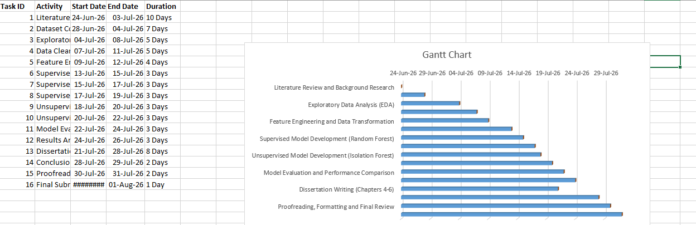

Appendix C: Artefact/Dataset
Dataset Link: https://www.kaggle.com/datasets/ziya07/financial-transaction-for-fraud-detection-research/data

